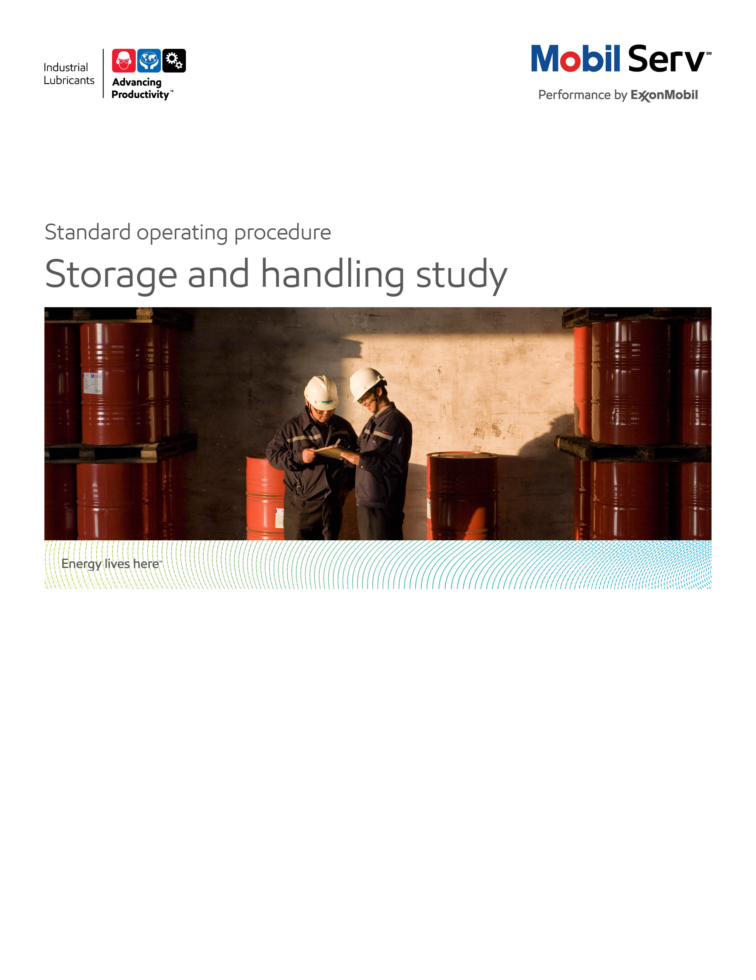

 

**Standard Operating Procedure** **(SOP)**

**Read all of the steps in this SOP before beginning work.** **Follow customer labor requirements (i.e. respect Union work)**

|  |  |  |  |  |  |  |
| --- | --- | --- | --- | --- | --- | --- |
| **SOP: Storage & Handling Study** | | | DATE  7/18/2014 | ⌧ NEW  REVISED  ___ Number | | PAGE 1 of 10 |
| TYPICAL CUSTOMERS  Gen. Manu., Prmary Metals, Cement, Mining, Energy, Pulp/ Paper, etc. | WORK TYPE  Lubricant Storage & Handling (S&H) Study | | WORK ACTIVITY (Description)  Perform a Lubricant Storage & Handling (S&H) study in order to ensure optimal lubrication | | | |
| **DEVELOPMENT TEAM** | **POSITION / TITLE** | | **REVIEWED BY/DATE** | | **POSITION / TITLE** | |
| Tom Schiff | Global FES Manager | | Thomas Schiff Aug 28, 2014 | | Global FES Manager | |
| Gilles Delafague | FES Advisor | |  | |  | |
|  |  | |  | |  | |
| **PLEASE UTLIZE ATTCHED GENERAL JSA AS GUIDANCE AND, IF YOU HAVE DONE A SITE SPECIFIC JSA.**  **PLEASE ASSESS YOUR OWN CONDITIONS OR SPECIFIC SAFETY REQUIRMENTS OR 3rd PARTY SITES, AND BE SAFE:** <http://intratta.na.xom.com/emdn/sbps/docs/safety/jsa/JSA_Storage_and_Handlng_Study.xls> | | | | | | |
| **EQUIPMENT INDEPENDENT OF JSA DESIRED DOCUMENTATION** | | | | | | |
| ⌧ CLIPBOARD OR IPAD / TABLET PC  ⌧ IR GUN  ⌧ FLASHLIGHT(with safety hand string)  ⌧ SAMPLE THIEF, BOTTLES & LABELS  ⌧ RAGS LINT FREE  ⌧ CAMERA (with safety hand string)  ⌧ IPAD WITH SITE STUDY APP | | ⌧ DATE OF – (ESN) Engineering Service Notice as a leave behind  ⌧ CUSTOMER UOA REPORTS (SIGNUM/DATA HARVESTER)  ⌧ FINAL – (ESR) Engineering Service Report OR PROPOSAL  ⌧ INSPECTION SPREADSHEET / IPAD SITE STUDY OUTPUT  ⌧ REPRESENTATIVE OIL CLEANLINESS SUPPLY CHAIN REPORT  ⌧ PLANT ANALYSIS IPAD APP OUTPUT  ⌧ CUSTOMER S&H PROCEDURES  ⌧ CUSTOMER S&H TRAINING PLAN/MATERIAL  ⌧ CUSTOMER CLEANLINESS GOALS BY APPLICATION  ⌧ CUSTOMER SAFETY RECORD (LUBE S&H RELATED INCIDENTS)  **OTHER (SPECIFY**) | | | | |
| **TIME ESTIMATED TO COMPLETE THIS TASK NUMBER OF PEOPLE TO PERFORM THIS TASK** | | | | | | |
| PLANNING – ½ DAY; SITE EXECUTION – 1 DAY; POST ANALYSIS – ½ DAY; REPORT GENERATION – ½ DAY | | TYPICALLY ONE LUBE ENGINEER WITH CUSTOMER ESCORT/ FOR LARGE FACILITIES MAY USE TEAM OF LUBE ENGINEERS, DISTRIBUTOR LUBE ENGINEERS/TECHNICIANS | | | | |
| **FREQUENCY TO PERFORM THIS TASK SKLLS REQUIREED TO PERFORM THIS TASK** | | | | | | |
| DEPENDS ON CUSTOMER NEEDS. ALSO DEPEND ON THE QUANTITY OF EQUIPMENT SELECTED BY THE CUSTOMER. TYPICALLY A STUDY IS CONDUCTED AS A PROJECT (ANNUAL+) AND CAN BE COMPLEMENTED BY ROUTINE INSPECTIONS ON MORE FREQUENT BASIS (BEST INCORPORATED INTO CUSTOMER OWN INSPECTION PROGRAM BUT EM CAN BUILD INTO OTHER INSPECTIONS OR HAVE DISTRIBUTOR/CONTRACTOR TECHNICIAN EXECUTE) | | ⌧ MECHANICAL APPTITUDE.  ⌧ PRODUCT KNOWLEDGE.  ⌧ FILTRATION/LUBE CLEABLINESS KNOWLEDGE.  ⌧ LUBE S&H EQUIPMENT KNOWLEDGE.  ⌧ EXPERIENCE WITH BREATHERS.  ⌧ CONTAMINATION CONTROL EXPERIENCE.  ⌧ TYPICAL PROBLEMS WITH CONTAMINATION.  ⌧ CONDITION EQUIPMENT DETAILED OBSERVATION  ⌧ WAREHOUSE AND STORAGE INSPECTION EXPERIENCE.  ⌧ SAMPLE TAKING EXPERIENCE.  ⌧ OIL ANALYSIS AND INTERPRETATION EXPERIENCE. | | | | |
| **JOB COMPETANCIES REQUIRED TO PERFORM THIS TASK** | | **TRAINING REQUIRED TO PERFORM THIS TASK** | | | | |
| ⌧ UOA INTERPRETATION  ⌧ SAMPLING TECHNIQUES  ⌧ BASIC LUBRICATION OF GEARS, BEARINGS, HYDRAULICS  ⌧ FILTRATION & DIALYSIS.  ⌧ PSPS (PROFESSIONAL SELLING PROCESS SKILLS) / SPIN  ⌧ TCO / BENEFIT REPORT WRITTING  ⌧ LUBE STORAGE, HANLDING AND DISPENSING | | ⌧ lms e-Learning– LUBE S&H  ⌧ 2nd Edition Lubrication Fundementals Book (Chapters 18 & 19)  ⌧ EM S&H Internal/External Offer Sheets  ⌧ Contamination Control Training (file attached)  ⌧ Product knowledge and Recommendations  ⌧ UOA Interpretation ( Cleanliness).  ⌧ Filtration & Dialysis. (file attached)  ⌧ OJT – observe competitent person doing S&H study  ⌧ OJT – be observed by competitent person doing S&H study  ⌧ Site specific safety training | | | | |
| **OTHERS RESORCES OR RELATED INTEREST SITES** | |  | | | | |
| ⌧ TECHNICAL HELP DESK (THD) ([tsc.amerias@exxonmobil.com](mailto:tsc.amerias@exxonmobil.com))  ⌧ Lube GBU Technical Resource Library  ⌧ www.mobilindustrial.com  ⌧ www.looble.com | | ⌧ LTS (LUBRICANT TECHNICAL SUPPORT) | | | | |

**PURPOSE** – To describe the process for developing a Lubricant Storage & Handling Study in a new or an an existing customer. The main objective through the Oil cleanliness study is to monitor the oil condition along the supply chain (from warehouse/tanks to different equipment) identifying sources of contamination in order to propose improvements for keeping clean the oil and to increase equipment life.

|  |  |
| --- | --- |
| **LOCATION** | **JOB STEPS** |
| Prior your call, collect customer information. | * Ask customer for personal protection equipment you will need previous to visit different locations. Review JSA, etc. * Identify customer sector and prep for suffering points for this industry (Example, Cement: a lot of contamination). * Determine why the Lubricant Storage & Handling Study is needed. What is the goal of the customer?. Identify cost or potential cost impacts due to poor lubricant storage and handling (leverage data harvester UOA results, removed equipment components that show failure modes of contamination, get store room part usage, etc.) * Get preliminary information: General equipment layout, Current Lube Routes, Current Lubricant used, Lubrication practices ( How they apply the lubricant, how they handle the oil, where do they store lubricants, what tool do they use to apply the lubricant), warehouses used for storage lubricants and what kind of filtration they use. * Get process diagrams to understand customer equipment and nomenclature. * Consult support information and owner/OEM manuals for cleanliness specifications. * Collect all used oil analysis information they have about the specific equipment. Ask for cleanliness information. Ask for the laboratory they use. * Get organization diagrams in order to know what people is responsible for lubricant application, oil filtering, oil storage, etc. * Ask customer for frequency of oil drain interval change and top off oil rates for major system consumers/ * Ask customer for visiting the equipment, the oil warehouse and tool warehouse (Some customers use one warehouse for sealed drums and other for drums that already open). * Be ready with SPIN questions regarding the equipment: Filtration, oil drain interval, samples, personnel, tools, etc. |
| Equipment inspection/Field Analysis | * Be accompanied by a customer representative. * Be aware of potential hazards close to the equipment. * Ultize the IPad Plant study tool to record information * Identified the objective of the equipment in the manufacturing process. * Review with the customer the path of the lubricant from storage to equipment fill – including purification steps along the path. Focus on critical equipment and especially focus on equipment that you identified has potential for TCO impacts due to poor storage and handling practices. * Review how the customer receives product. Do they take a sample when they receive bulk for retain, do they compare the sample for clear and brightness against a reference. When critical cleanliness requirement do they check the particle count (themselves or by supplier) * Anayze if they store there oil to utilize first in/first out management control * Anayze their storage drums/pails to prevent safety incidents while in storage or handling * Anayze if they stage the main oil storage and satellite storage areas to optimize travel time for lubrication handlers as well as minimize environmental contamination impacts * Determine if the customer understands how to determine the package product shelf life and do they check their slow moving inventory shelf life * Check if the customer has good and written lubricant storage and handling procedures/expectations * Evaluate if the customer has a formal lubricant storage and handling program for the appropriate personnel * Check if the customer has a periodic/routine (e.g. monthly walk arounds by appropriate management) lubrication storage and handling assessment (someone surveys the lube storage sights to observe for deviations from expectations) * Take notes of the brand and models of the equipment and the components. See if there are filters attached to the equipment. Ask for the information about those filters (Brand, Model, Beta, change frequency). Ask how they know when they have to change the oil. * See if there is any label attached to the equipment and storage/dispensing equipment that show basic information like oil used, date of oil changed, refill, etc. How they use visual management to avoid cross-contamination. * Review customer’s purification equipment used in the lubricant supply or reclaimation chain. Take notes of brand, model, filters quantity, beta and change frequency. If it is possible ask the customer if you can see how they purify the oil (Look for potential issues). Take samples before and after the purification processes. * Select key lubrication supply chains and take oil samples for cleanliness/contamination determination from distributor to customer receiving, to main oil storage, to satellite oil storage and to equipment as well as the transfer devices. * Review customer on site equipment rebuild shop’s (e.g. machine shops, pump rebuild shops, roll shops, mobile equipment shops, etc.) lubricant storage and handling procedures and actual practices * Review customer off site equipment rebuild shop’s (e.g. other vendors that repair/build customer rotating equipment) lubricant storage and handling procedures and actual practices * Review customer equipment construction/project lubricant storage and handling procedures as well as procedures to align with rest of facility fewest correct lubricants. Also review lubrication hand over procedures that ensure the new equipment is properly lubricate prior to hand over to the facility * Evaluate high lube consumption applications/equipment as they can drive more oil handling and ingression to determine opportunities to reduce consumption (good to reduce lube usage as well as reduce potential for contamination ingression from new oil being added) * Inspect customer’s all loss central lubrications systems (oil, grease, mist) to determine how do they transfer lubricant into these devices, do the devices have labels, do they have appropriate filters, etc. |
| Equipment inspection/Field Analysis | * Create a list of current lubricants, delivery container sizes and usage by department using storeroom, lube storage areas and lube cabinets. * Observe the warehouse used for storage the oil ( Ceiling, floor, walls). Ask the customer if there is only for oil, how they prevent contamination in the room. Does the area have proper temperature control. * Assess any outside lubricant storage for proper sheltering, oil drums stored in right position, drum cover use, etc. * Observe the lubricant storage areas for basic housekeeping opporutnities (floors clean, lids/caps always used, labels in place, etc.) * Observe types of containers (Bulk, drum or pail) and their appropriateness for type of use/application * Observe the equipment used to deliver the oil (pneumatic pump, manual pump, etc.). See if there is one pump for one kind of oil. Observe how the tip of the gun is. Identify potential issues. * Observe if they use breathers on the drums or the bulk tanks. * Assess if the customer uses decicant (some gases use gravity separation units where higher humidity exists) breathers on drums or bulk tanks in areas with moisture. * Assess bulk tanks to determine if proper tank atmospheric padding/ventilation is in place. Typically use dry/clean instrument air or dry/clean nitrogen. * Determine if customer has appropriate drain ports on storage tanks and cracks them periodically to inspect for water/particulate contamination. In addition, best practice is that the bulk tank is sloped downward to the drain (approximately 1 down to 10 across slope demension) and away from the dispenser pick up. * Assess the customer bulk tanks for proper inventory management including low level alarming, inspection routines, procedures to expedite lubricant orders from supplier, written supplier supply expectations, and periodic quality sampling (especially when bulk oil feeds into equipment sensitive to contamination). * Assess customer oil transfer equipment to determine if they have appropriate filtration. In addition, assess critical applications for filtration on the equipment reservoirs and devices like specific connectors to prevent cross contamination with other lubes/liquids (color coded hose/pipe connectors with different demensions than other systems so someone can not hook up the wrong connector/hose). * Ask if they purify new oil. Ask for used oil analysis information . If is is possible take a sample before and after the dialysis. Ask for the information of the equipment use to purify new oil (Brand, Model, quantity of filters, beta, change frequency). * For customers with high grease consumption, assess if they have the optimium dispensing equipment. For sites that require mobility they should have portable kegs with pumps (if pneumatic ensure proper pressure regulation, air hose size, grease hose length/diameter – big impact on flow rate, and clean/dry air). Also determine for specific applications or central storage areas that containers like grease bag systems or fixed bulk systems are used instead of drums. * Observe types of containers for preventing ingression of contaminants (are they sealed, are they labeled). Are they use funnel? How clean is the funnel? Are the funnels dedicated, labeled, stored in clean place, are they cleaned after each usage. * Review if containers are dedicated by product * Observe the oil container labeling ( Drums, pails, small containers). How they use visual management to avoid mistakes. * Make a general note on housekeeping of containers and materials management. * Determine if the customer has proper oil spill clean up material, expectations and training. * Assess customer for proper oil disposal facilities (didcated, marked containers), procedures, training, etc. * Determine if the customer lubricant storage facility complies with appropriate regulations (country, state/region/providence, local, and company) * Observe the tools they use to apply the lubricant. Are they labeled?. Are they proper storage?. * Take photographs with customer’s permission.   At the end of the visit write an Engineering Service Notice to the customer, highlighting the main items covered, agreements next steps, and timeframe |
| Home Office – analyzing all data (Information Analysis) | * Send samples to the lab. Ask for particule counter analysis. * Confirm the lubricant used in the equipment to ensure they customer is using the fewest correct lubricants. Utlize OEM Manuals, Technical Help Desk, Looble, EMEBS, EB Engineer, etc. * Consult with purification/filtration/lube transfer equipment specialist (other vendors). Confirm purification and transfer equipment are optimized. * Ask your colleagues about similar situations and how they were solved. * Review in Inside Sales – Technical – Model Reports and the VDR site for similar applications, products and how others have built a benefit report. * Factor investment costs for storage/handling/purification upgrades * Review the photos and mark the issues. Find photos with best practices in order to compare. |
| Prepare the ESR | * Using the 3D Report Writer format, prepare the ESR. Store in Value Document Repository (VDR) * Apply the applicable TCO Categories: Revenue, Assets, Process, Expenses and Others. * Use photos to explain your findings. Use best practices. |
| Set a follow up meeting with customer to review draft. | * Confirm with the customer the findings and explain why you thing are potential issues. Use support data like used oil analysis, OEM recommendations and other customer best practices. * Explain your recommendations and the necessary changes to meet the goal. * Explain the next steps to achieve this value and express as opportunities for improvement. |
| Manage implementation and expand relationships | * Get customers cooperation to implement your recommendation – colloaborate with customer to arrive at recommendations * Offer your technical post-sale expertise expand relationships |
| Feedback about this SOP - send Chief Engineer |  |

**Storage inspection examples.**

* Take notes about quantity of oils used in the plant.
* Identify if the storage is for close or open drums or pails.
* Identify if the warehouse is close or is in an open space.

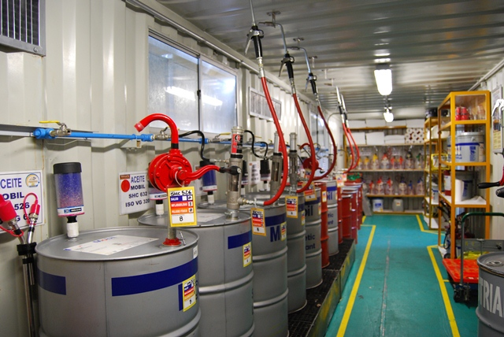

See the tip of the gun for any trail of contamination

Identify if there is one pump per product.

Take notes about how clean is the warehouse

Indentify Breathers

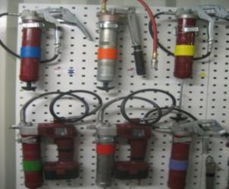

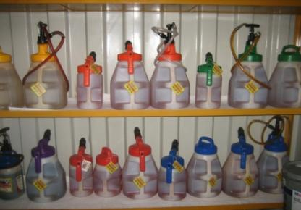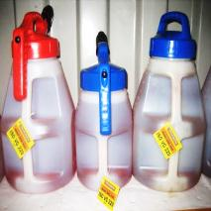

Fuente: MYSRL

How the customer avoid cross contamination

Indentify the type of packaging used for fillings

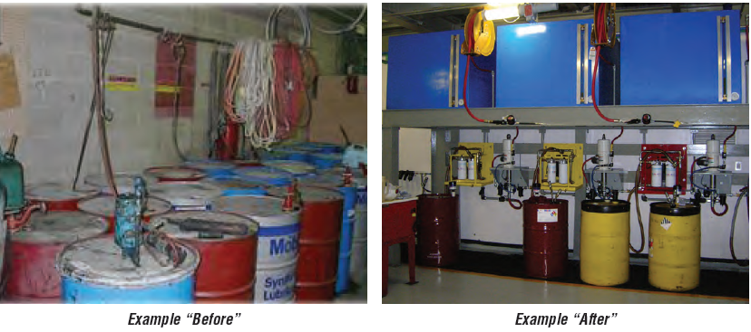

**Before**

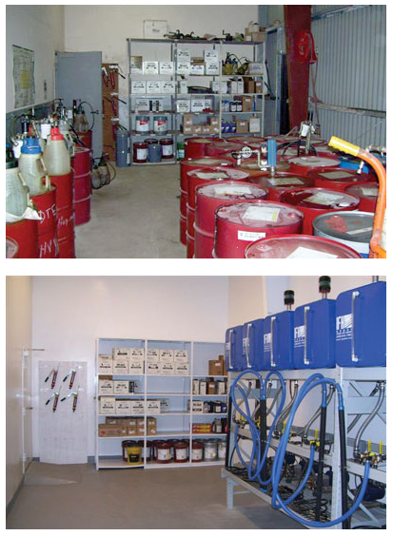

**After**

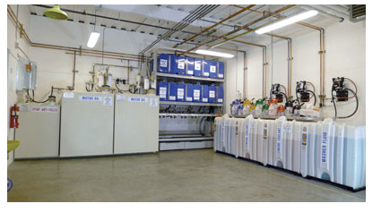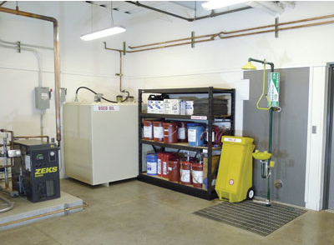

World Class

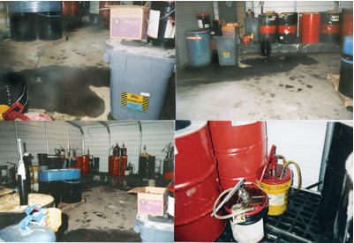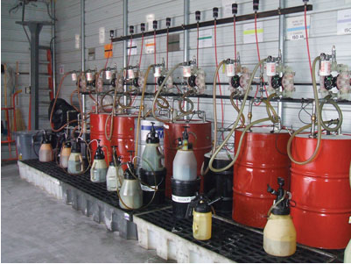

Before After

**Before – Everything Exposed**

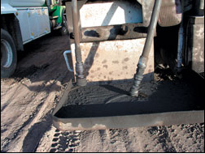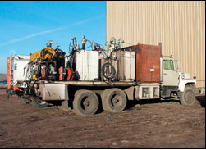

**New Design - Enclosed**

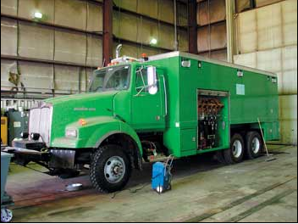

**Mine Bulk Best Class (labeling, breathers, filters-receive, recirculate, feed, level monitor/alarm)**

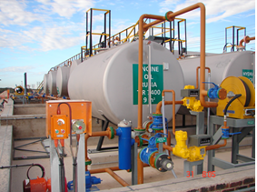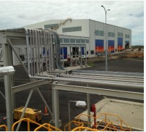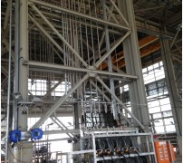

**State of the art mine fuel and lube truck with enclosed dispensing with meters, filtration**

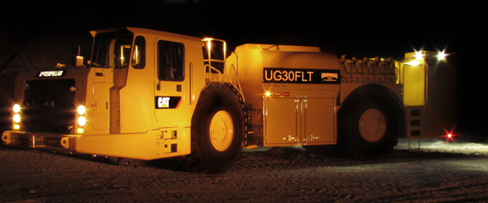

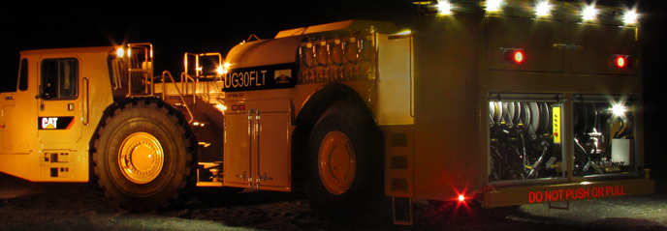

**APPENDIX 1 - RELATED DOCUMENTS**

* **Model Engineering Service Reports/Proposals**

[**Product Consolidation Example**](http://ishareteam2.na.xom.com/sites/LSSG031/TechResources/Tech%20Resources%20Docs/Product%20Consolidation.pdf)

[**General Manufacturing S&H Example**](http://ishareteam2.na.xom.com/sites/LSSG031/TechResources/Tech%20Resources%20Docs/Product_Consolidation_Gen_Manu.pdf)

[**Mining S&H Example**](http://ishareteam2.na.xom.com/sites/LSSG031/TechResources/Tech%20Resources%20Docs/Mining_and_Construction_Storage_and_Handling.pdf)

[**Grease Gold Bag Example**](http://ishareteam2.na.xom.com/sites/LSSG031/TechResources/Tech%20Resources%20Docs/Mining_and_Contruction_Storage_and_Handling_Gold_Bag_Example.pdf)

[**Pulp & Paper S&H Example**](http://ishareteam2.na.xom.com/sites/LSSG031/TechResources/Tech%20Resources%20Docs/Storage_and_Handling_Paper.pdf)

[**Power Plant S&H Example**](http://ishareteam2.na.xom.com/sites/LSSG031/TechResources/Tech%20Resources%20Docs/Sector_Power_Generation_Service_Oil_Storage_and_Handling_Study.pdf)

* **TCO Categories**

**Revenue Examples**

* + Equipment downtime due to failure caused by contamination stemming from poor lube S&H
  + Equipment down time due to poor lubricant inventory management (run out of oil)

**Expenditure Examples**

* + Lubricant usage due to replacing from S&H contamination
  + Less than optimial equipment component life due to contamination from poor S&H
  + Increased lube costs due to damaged lube containers/spills
  + Increased costs due to fines for safety/environmental fines
  + Potential increase investment costs to purchase new/upgraded S&H equipment

**Asset Examples**

* Increased inventory carry costs due non optimal inventory management
* Increased inventory carry costs due to not having the fewest correct lubricants
* Increased inventory costs due to less than optimal machinery inventory due to frequent repair from poor S&H
* Increased labor costs to transfer and apply lubes due to less than ideal storage locations
* Increased asset carry costs for new S&H equipment

**Process (labor) Examples**

* Increased labor costs due to additional lube disposal from poor S&H
* Increased labor costs due to repair equipment from poor S&H
* Increased labor costs to transfer and apply lubes due to less than ideal storage locations
* Increased costs to install new S&H equipment

**Safety Examples**

* Increase machinery risks exposure due to more frequent lube addition to equipment from poor S&H
* Increase machinery risks exposure due to more equipment repair from poor S&H
* Increase machinery risks exposure due to more lube leaks from poor S&H
* Increased machinery risk exposure from less than ideal lube storage locations and extra travel

**Enviromental Examples**

* Increased waste lube volume due to additional lube disposal (shorter oil life) from poor S&H
* Increased environmental impact exposure due to lube leakage from poor S&H
* **S&H Equipment Examples**

[**http://descase.com/products/fluid-handling-filtration/**](http://descase.com/products/fluid-handling-filtration/)

[**http://descase.com/products/lubrication-transformation-services/design/lube-room-design/**](http://descase.com/products/lubrication-transformation-services/design/lube-room-design/)

[**http://www.rock-tech.net/**](http://www.rock-tech.net/) **- for underground mine lube storage solutions**

* **Filtration Information**

[**http://ishareteam2.na.xom.com/sites/LSSG031/TechResources/Tech%20Resources%20Docs/Filtration.ppt**](http://ishareteam2.na.xom.com/sites/LSSG031/TechResources/Tech%20Resources%20Docs/Filtration.ppt)

[**http://www.pall.com/main/industrial-manufacturing/pocket-book-contamination-and-filtration-42674.page**](http://www.pall.com/main/industrial-manufacturing/pocket-book-contamination-and-filtration-42674.page)

[**http://ishareteam2.na.xom.com/sites/LSSG031/TechResources/Tech%20Resources%20Docs/Beta%20Ratio%20Technical%20Bulletin.ppt**](http://ishareteam2.na.xom.com/sites/LSSG031/TechResources/Tech%20Resources%20Docs/Beta%20Ratio%20Technical%20Bulletin.ppt)

* **Contamination Control**

[**http://ishareteam2.na.xom.com/sites/LSSG031/TechResources/Tech%20Resources%20Docs/Contamination%20Control%20Basics.pdf**](http://ishareteam2.na.xom.com/sites/LSSG031/TechResources/Tech%20Resources%20Docs/Contamination%20Control%20Basics.pdf)

* **Other Storage and Handling Reference Material**

<http://ishareteam2.na.xom.com/sites/LSSG031/TechResources/Tech%20Resources%20Docs/Lubricant%20Storage%20Basic%20Guide.pdf>

<http://ishareteam2.na.xom.com/sites/LSSG031/TechResources/Tech%20Resources%20Docs/tt-handling-and-storing-lubricants.pdf>

<http://ishareteam2.na.xom.com/sites/LSSG031/TechResources/Tech%20Resources%20Docs/TIS-17_Dispensing_Lubricants.doc>

<http://ishareteam2.na.xom.com/sites/LSSG031/TechResources/Tech%20Resources%20Docs/tt-safety-in-lubrication.pdf>