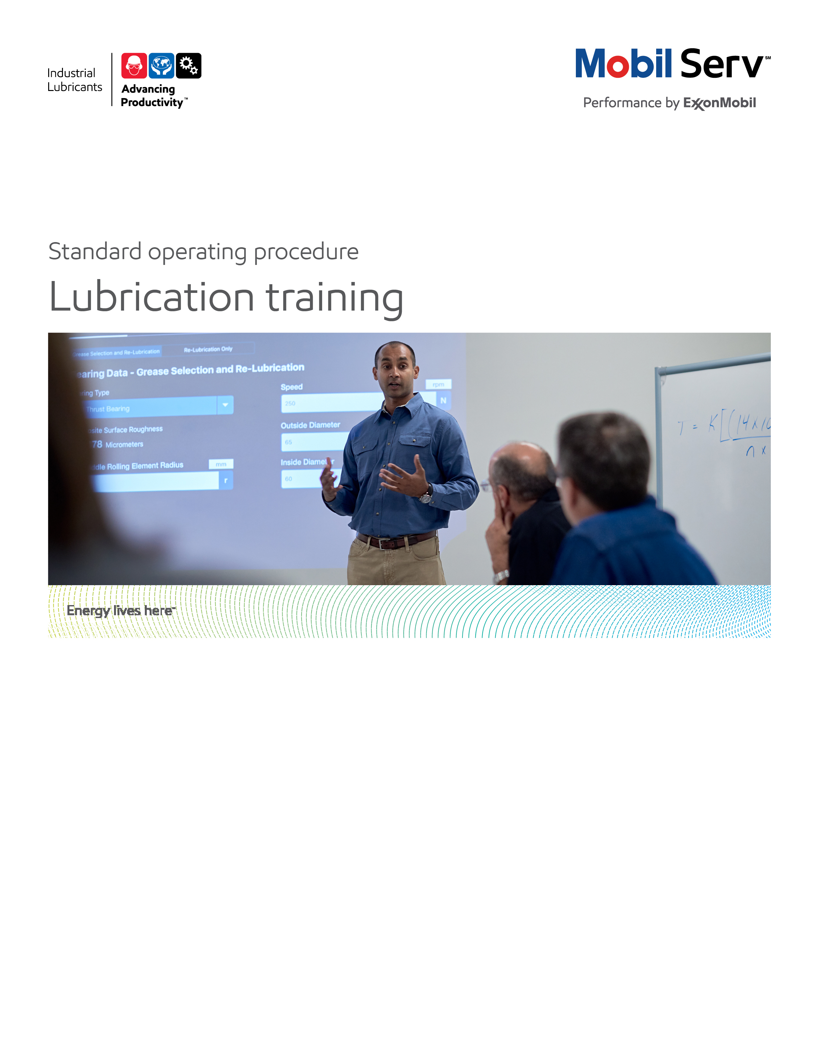
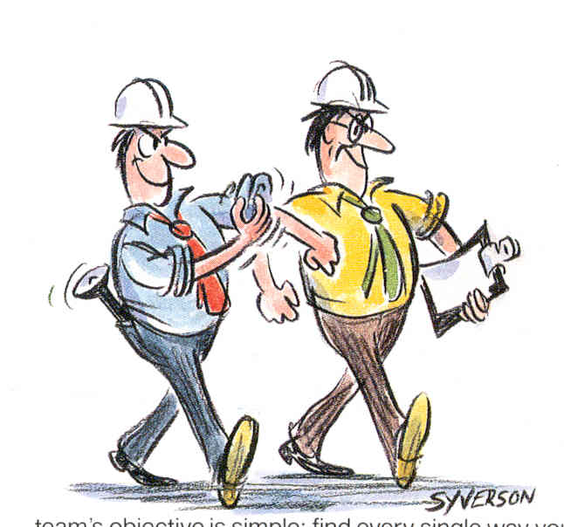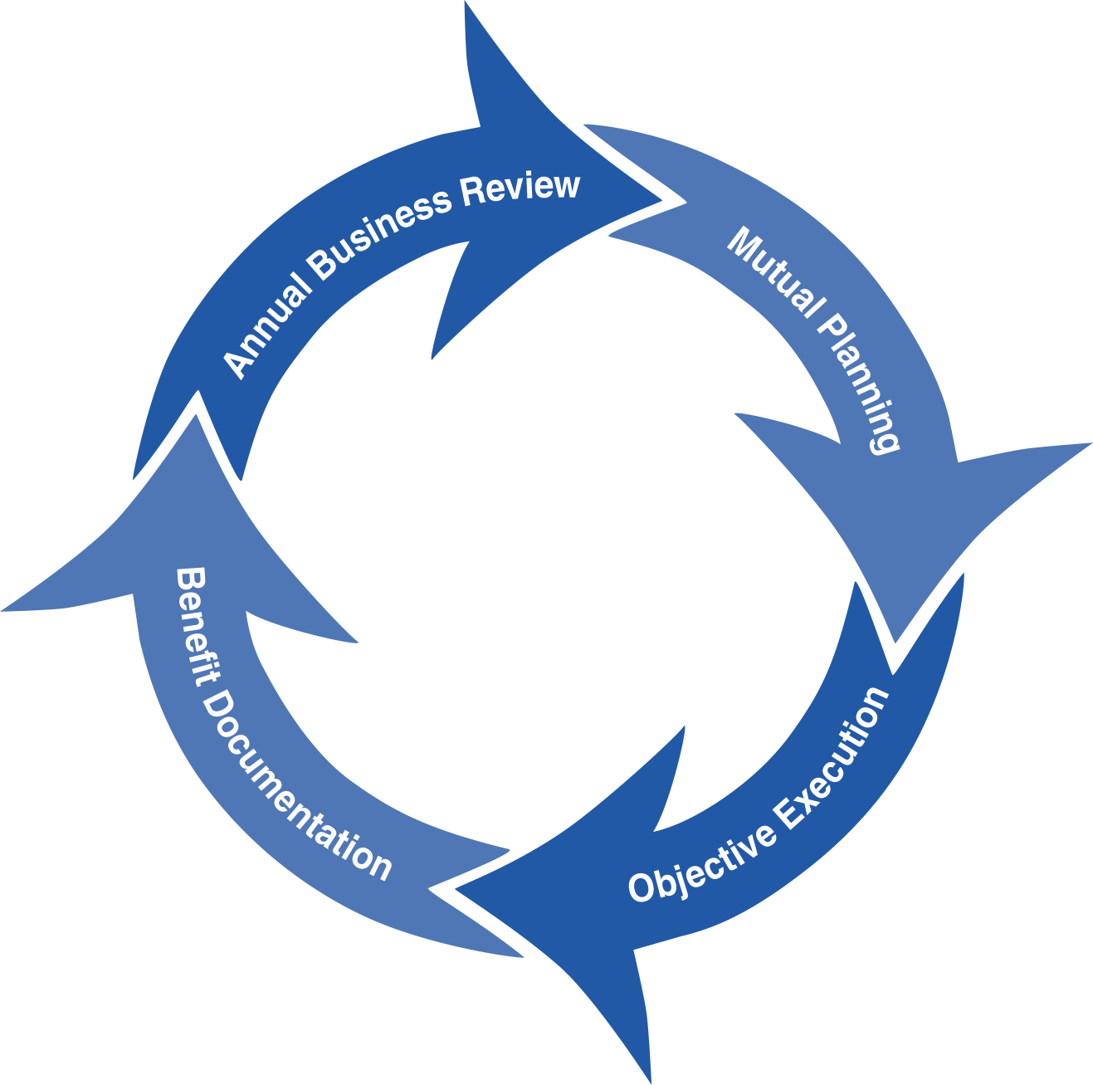
Standard Operating Procedure (SOP)
Read all of the steps in this SOP before beginning work. Follow customer labor requirements (eg respect Union work)

SOP: Customer Training |  | DATE  5/7/2015 |  NEW  o REVISED  ___ Number |  | PAGE 1 of 6
TYPICAL CUSTOMERS  Various: PAPER, PLASTICS, GEN MFG, ENERGY OFF HIGWAY,ETC. | WORK TYPE  CUSTOMER TRAINING | WORK ACTIVITY (Description)  Steps and recommendations to follow to properly conduct customer training. This SOP covers basic, advanced, and certification customer training.
DEVELOPMENT TEAM | POSITION / TITLE | REVIEWED BY/DATE |  | POSITION / TITLE
Tom Schiff | Global FES Manager | Tom Schiff 22May2015 |  | Global FES Manager
Gilles Delafargue 19May2015 | Global FES Advisor
PLEASE UTLIZE ATTCHED GENERAL JSA AS GUIDANCE AND, IF YOU HAVE DONE A SITE SPECIFIC JSA.
PLEASE ASSESS YOUR OWN CONDITIONS OR SPECIFIC SAFETY REQUIRMENTS AND BE SAFE. Customer Site Training JSA
EQUIPMENT INDEPENDENT OF JSA DESIRED DOCUMENTATION
 LAPTOP/IPAD   PROJECTOR/FLIPCHARTS   TRAINING PRESENTATION THAT MAY INCLUDE PICTURES OR VIDEOS OF CUSTOMER SPECIFIC EQUIPMENT/ISSUES FOR DEMONSTRATION   SUBJECT MATTER HANDOUTS   ATTENDEE SIGN IN SHEET   EXAMPLE OIL SAMPLES, EQUIPMENT COMPONENTS, ETC.   CAMERA FOR GROUP PICTURE (IF APPROPRIATE)   TRAINING CERTIFICATES FOR ATTENDEES   MOBIL SERV REPORT WRITER  CHECK WITH CUSTOMER : OK TO USE OWN TOOLS OR MUST BE CUSTOMERS   TRAINING EVALUATION FORMS |  |  DAY OF - ENGINEERING SERVICE NOTICE (ESN) AS LEAVE BEHIND FOR ANY IMMEDIATE FOLLOW UP ITEMS IDENDIFIED DURING THE TRAINING SESSIONS   FINAL - ENGINEERING SERVICE REPORT (ESR) OR ENGINEERING SERVICE LETTER (ESL) WITH TOTAL COST of OWNERSHIP (TCO) SAVINGS  OTHER (SPECIFY)   ATTENDEE LIST   EQUIPMENT INSPECTION CHECK SHEETS/TEMPLATES/CALCULATORS FOR ANY TRAINING SESSION FOLLOW UP ITEMS   LUBRICATION, PREDICTIVE MAINTENANCE (E.G. OIL SAMPLING) OR OTHER PROCEDURES TO SUPPLEMENT TRAINING
TIME ESTIMATED TO COMPLETE THIS TASK NUMBER OF PEOPLE TO PERFORM THIS TASK
BASIC TRAINING – PER SUBJECT 1 HOUR FOR UNDERSTANDING CUSTOMER NEEDS/IMPACTS/PREPARATION, 1 HOUR FOR TRAINING DELIVERY, 2 TO 4 HOURS FOR FOLLOW UP ACTIONS, 2 HOURS FOR DOCUMENTATION  ADVANCED TRAINING – 1 TO 2 HOURS FOR UNDERSTANDING CUSTOMER NEEDS/IMPACTS/PREPARATION, 1 TO 4 HOURS FOR TRAINING DELIVERY, 2 TO 4 HOURS FOR FOLLOW UP ACTIONS, 2 TO 4 HOURS FOR DOCUMENTATION  CERTIFICATION TRAINING - 1 TO 2 HOURS FOR UNDERSTANDING CUSTOMER NEEDS/IMPACTS/PREPARATION, 2 TO 5 DAYS FOR TRAINING DELIVERY (depending on number of attendees/sessions), 2 TO 4 HOURS FOR FOLLOW UP ACTIONS, 4 TO 8 HOURS FOR DOCUMENTATION |  | 1 CAPABLE EM OR DISTRIBUTOR PERSON  1 CUSTOMER PERSON TO ESCORT FOR TRAINING FOLLOW UP ACTIVITIES AT THE CUSTOMER SITE AS APPROPRIATE (E.G. EQUIPMENT INSPECTIONS, ETC.)
FREQUENCY TO PERFORM THIS TASK COMPETENCIES/SKLLS REQUIREED TO PERFORM THIS TASK
DEPENDS ON CUSTOMER COMMITMENTS, USUALLY 1 TIME PER YEAR, FOR CERTIFICATION TRAINING MAY BE LESS FREQUENT |  |  CUSTOMER EQUIPMENT UNDERSTANDING AND ASSOCIATED LUBRICANTS AND LUBE APPLICATION KNOWLEDGE FOR THOSE APPLICATIONS   CLASSROOM AND ON THE JOB (OJT) TRAINING PRESENTATION SKILLS   APPROPRIATE PREDICTIVE MAINTENANCE KNOWLEDGE   SPIN SELLING SKILLS   TOTAL COST OF OWNERSHIP (TCO) SKILLS   ROOT CAUSE ANALYSIS SKILLS FOR EQUIPMENT SUFFERING POINTS ASSOCIATED WITH THE TRAINING
 |  | TRAINING REQUIRED TO PERFORM THIS TASK
 PRODUCT KNOWLEDGE AND RECOMMENDATIONS
 EQUIPMENT APPLICATION (INCLUDING LUBE APPLICATION)
 TROUBLE SHOOTING PROBLEMS/FAILURE ANALYSIS
 EQUIPMENT INSPECTIONS
 ENGINEERING REPORT WRITING/TCO
OTHER RESOURCES REQUIRED OR SUPPORT
 TRAINING DECKS – STANDARD DECKS/MARKETING APPROVED – CAN BE ADAPTED TO INCLUDE CUSTOMER SPECIFIC EQUIPMENT PHOTOS/VIDEOS – CAN ALSO INCLUDE PRE/POST TRAINING QUIZES   LUBES GBU TECHNICAL RESOURCE LIBRARY   THUNDER TRAINING DECK FOR CUSTOMER TRAINING |  | TECHNICAL LINKS   Customer Training Decks

PURPOSE - To describe the typical steps of conducting customer training on lubrication/equipment reliability subjects with the desired reporting that provides the value back to the customer, to support the Marketing Offer.

External Offer Sheet: TBD
Basic training
Advanced training
Certification training
Internal Offer Sheet: TBD
Basic training
Advanced training
Certification training

LOCATION | JOB STEPS
Preparation - Data Gathering to prepare the appropriate training and case for action as well as administration | Understand and gather the following information:  - Identify what value the training will bring – what specific advancing productivity customer goals will it meet/what suffering point will it help solve? – be specific and tie to monetary impact.  - Typically we should avoid relying on standard training value estimates (e.g. training increases employee productivity by 1% per year) or the time required for us to prepare and deliver the training. The main value should come from understanding the customer’s equipment reliability needs/suffering points and tying the training to these needs/suffering points. The value should come from potential or actual avoided equipment reliability costs/impacts by having customer employees/contractors better capable to address the suffering points. We should only use avoided training costs due to our labor (associated with our time to conduct the training) as our documented value if it is significant (e.g. for certification training unless we charge for the training) or if we train many employees (e.g. over 50). Using avoided training costs under these circumstances should be secondary to the improved equipment reliability value documented.  - Collecting this “case for action” information (including how the training will help address the root cause of the suffering point/opportunity) prior to the training helps achieve highest impact value documentation by getting the customer to quantify the value of the training. This also places the case for action and priority of the training and does not make the training a “nice to do” activity that can be postponed or never completed. In addition, by having the value understood upfront, the customer has set a goal to reach that can be leveraged in the training “case for action” that helps the attendees understand the importance of why they are receiving the training.  - If customer delays/postpones training then test to make sure the training is tied to important business goals/suffering points.  - Training sessions also provide an opportunity to uncover further suffering points brought up by training session attendees that we can follow up after the training. Once these potential suffering areas surface, we should understand the value and conduct inspection/produce recommendations if they yield significant value. A best practice is to send the attendees a survey prior to the training session to come prepared with the biggest issues/challenges/questions they may have. Also providing some recognition (within CIMS guidelines) for contributing. We may also be able to tie the attendee contributions coming from the training sessions to customer recognition programs.  - After identifying suffering points from the customer, go into the facility to take pictures (if allowed) of the suffering points as well as corrective actions (proper oil level, procedures, etc.) to include in the training deck. This is typically done for advanced training classes.  - Identify the number of participants to attend the sessions. Try to keep the number under 15 in each session to promote more interaction.  - For certification training, ensure to block enough time for breaks, quiz taking/reviews, and meal  - Set up the training times preferably at the start of the day/shift while the attendees are fresh. Best to have coffee/some refreshments in the class.  - Prepare or ensure preparation of the training venue ahead of time. If at a customer’s site, ensure the room is adequate for the class size, arrange for enough chairs and tables, have a flip chart or writing board available for explaining concepts or logging questions/issues.  - Best practice is to provide each attendee with a presentation handout to facilitate taking notes or have for future reference.  - Confirm with customer contact the plan and if ok to do recognitions or provide tokens of appreciation (pens, hats, etc.)
Conducting the Training - Basic | - Start each session with classroom safety as well as share a safety minute to promote safety/share best practices  - Ensure to state the case for action to the attendees; best to tie to solving a suffering point, avoid seeming to blame the attendees for the suffering point but rather position as ways to improve/make their lives better  - Have attendees sign an attendee list to be able to put in ESR/ESL appendix as well as provide a means to produce attendee certificates; some customers want the list of names for their training records  - Run an interactive class, engage the attendees, ask questions, provide small prizes for answering, recognize with small prizes attendees that ask good questions or bring up potential suffering points  - Deliver the training using standard subject decks  - Do not hesitate to repeat/reinforce concepts for better assimilation by attendees  - Follow up on issues identified in the training  - Send customer attendee attendance sheet  - Ensure that Training evaluation Forms are duly filled in by attendees
Conducting the Training - Advanced | - Start each session with classroom safety as well as share a safety minute to promote safety/share best practices  - Ensure to state the case for action to the attendees; best to tie to solving a suffering point, avoid seeming to blame the attendees for the suffering point but rather position as ways to improve/make their lives better  - Have attendees sign an attendee list to be able to put in ESR/ESL appendix as well as provide a means to produce attendee certificates; some customers want the list of names for their training records  - Run an interactive class, engage the attendees, ask questions, provide small prizes for answering, recognize with small prizes attendees that ask good questions or bring up potential suffering points  - Deliver the training using standard subject decks but then customize to focus on the suffering points identified.  - Best practice is to provide the attendees a quiz on the subject to help ensure subject matter understanding  - In some cases, combine the classroom training with live demonstrations (e.g. how to grease a coupling, take oil sample, etc.) in the facility or repair shop (following appropriate safety steps)  - In some cases, create/supply lubrication procedures/examples  - Do not hesitate to repeat/reinforce concepts for better assimilation by attendees  - Follow up on issues identified in the training  - Send customer attendee attendance sheet  - Ensure that Training evaluation Forms are duly filled in by attendees
Conducting the Training - Certification | - Start each session with classroom safety as well as share a safety minute to promote safety/share best practices  - Ensure to state the case for action to the attendees; best to tie to solving a suffering point, avoid seeming to blame the attendees for the suffering point but rather position as ways to improve/make their lives better  - Have attendees sign an attendee list to be able to put in ESR/ESL appendix as well as provide a means to produce attendee certificates; some customers want the list of names for their training records  - Run an interactive class, engage the attendees, ask questions, provide small prizes for answering, recognize with small prizes attendees that ask good questions or bring up potential suffering points  - Deliver the training using standard subject decks but then customize to focus on the suffering points identified.  - Follow up section with a quiz and review the quiz answers, have an final test (can be open or closed book) to verify certification  - Do not hesitate to repeat/reinforce concepts for better assimilation by attendees  - Follow up on issues identified in the training  - Send customer attendee certification sheet  - Ensure that Training evaluation Forms are duly filled in by attendees
ESR (Engineering Service Report)/ESL(Engineering Service Letter) to customer | - If applicable write an Engineering Service Notice (ESN) after you leave customer site to review preliminary summary of the training session (s), opportunities identified during the training, follow up activity/recommendations on those opportunities, or plans for future cooperative work.  - Once you have address (produce recommendations) the opportunities/issues brought up during the training or confirm that the training address the specific customer suffering point (accomplish by verifying with your customer contact), write an Engineering Service Report or a Proposal (if short/noncomplex recommendations using an Engineering Service Letter is acceptable), identifying potential customer benefits based on the execution of ExxonMobil recommendations. Use pictures to highlight supporting ideas and inspection details of equipment.  - The ESR or Proposal should include savings using as many TCO categories as they apply, revenue enhancements, expenses, assets, process improvements, etc.  - The ESR or Proposal should include next steps and commitments.
Sending customer reports | - It is recommended to send the report directly to the maintenance contact, then arrange a meeting to discuss live and obtain approval. Once the report has been approved you may write a performance summary and share with other departments/upper management as appropriate.
Follow up | - In the next visits to customer site take a look to the corrective actions implemented as a result of your report.
Feedback about this SOP - Send to Chief Engineer
DOCUMENTING YOUR WORK – Customer training is used to assist customer reach their equipment reliability goals by increasing the lubrication related skills of their employees or contractors. The training should address potential or actual suffering points recognized/valued to be solved by the customer. Persons conducting the training should document the training, case for action, follow up recommendations and their value using Mobil Serv Report Writer and TCO approach.

- Typically we should avoid relying on standard training value estimates (e.g. training increases employee productivity by 1% per year) or the time required for us to prepare and deliver the training. The main value should come from understanding the customer’s equipment reliability needs/suffering points and tying the training to these needs/suffering points. The value should come from potential or actual avoided equipment reliability costs/impacts by having customer employees/contractors better capable to address the suffering points. We should only use avoided training costs due to our labor (associated with our time to conduct the training) as our documented value if it is significant (e.g. for certification training unless we charge for the training) or if we train many employees (e.g. over 50). Using avoided training costs under these circumstances should be secondary to the improved equipment reliability value documented.

Collecting this information prior to the training helps achieve highest impact value documentation by getting the customer to quantify the value of the training. This also places the case for action and priority of the training and does not make the training a “nice to do” activity that can be postponed or never completed. In addition, by having the value understood upfront, the customer has set a goal to reach that can be leveraged in the training “case for action” that helps the attendees understand the importance of why they are receiving the training.

Training sessions also provide an opportunity to uncover further suffering points brought up by training session attendees that we can follow up after the training. Once these potential suffering areas surface, we should understand the value and conduct inspection/produce recommendations if they yield significant value. A best practice is to send the attendees a survey prior to the training session to come prepared with the biggest issues/challenges/questions they may have. Also providing some recognition (within CIMS guidelines) for contributing. We may also be able to tie the attendee contributions coming from the training sessions to customer recognition programs.

Example: Customer has experienced gearbox failures due to low oil level since the customer lubricators did not understand how to read the oil sight glasses. This resulted in $400,000 of lost production, $150,000 in gearbox repair materials, and $20,000 of maintenance labor per year. By delivering training to the lubricators, they know understand the importance of lubrication and specifically how to read those specific sight glasses. The documentation should tie the training to the potential or actual improvement in the above gearbox issues.

TCO is a process to quantify improved profit through the implementation of an effective lubrication program. In order to document savings involved in a partnership between the customer and Mobil Industrial Lubricants, the following categories of value-added savings will be reviewed:

- Revenues
- Assets
- Processes
- Expenditures

The TCO Worksheets are the preferred format to include in your report. Proper placement is an Appendix. Additional guidance will incorporate our messaging of TCO to include Sustainability, Safety and Productivity relationships. Quantify these costs on an annual basis. We should use customer cost/impact data. If the customer does not know the numbers then utilize estimates from experience or other resources (repair shops, OEMs, etc.) then have the customer agree to the numbers/impacts.

Expenditure Reduction - reduced equipment and/or lubricant purchase costs are the most typical expenditure savings. These may result from the offset of extending lube application intervals from the previous lubricant or greases against the increased price of Mobil products flagships and premium or other recommendations to modify the lubricated equipment, lubricant delivery, lubricant purification systems, etc.)

Process Improvement - the hourly wages (including burden) for personnel to perform existing tasks e.g. replaces the lubricant or repair equipment reduced in part by the training. If equipment replacements or lubricant change outs are reduced, use these to determine Process improvements. If lubricant usage is reduced, use the time to handle drums and the time to dispose of used lube to determine Process improvements.

Revenue Enhancement - any repair for equipment failure may be repaired during normal maintenance and reduce the potential for downtime. “Unscheduled Downtime”, results in lost production and most often, scrapped parts or material. This may allow the customer to plan for a replacement during a planned outage instead of an emergency shutdown

Asset Improvement - use the customers "cost to carry" inventories. This is used from the Expenditures components for example, if you reduce the quantity of lubricant needed, take that amount cost and multiply by the "cost to carry" to determine the Asset value.

Safety Improvement – this is typically man-hours of avoided equipment interface exposure by increasing time between lubricant application/changes, reduced equipment repairs, etc. This could also include incidents caused by slips but do not document improvements in actual number of accidents or incident rates but rather the potential to impact those statistics.

Environmental Improvement – this is typically quantified by reduced lubricant volume disposed or reduced CO2 emissions

Refer to Expenditure Reduction, Process Improvement, Revenue Enhancement, and Asset Improvement to develop TCO. The Total Cost of Ownership (TCO) Database has many equipment typical costs in it, or consults with the OEM or equipment distributor to finalize your TCO. In all cases, ensure your customer agrees with the cost estimates. Sometimes you may need to suggest an estimated cost and get the customer to agree/negotiate to acceptable figures.

TCO Database

Include any “negative” components of TCO from your recommendations; new lube systems, filtration, water removal, enhanced predictive monitoring, increased labor (to do the job correctly the first time), new equipment; e.g. to replace under sized equipment.

Documentation Links:

Standard training presentations/quizzes (can also be used for Certification Training):
Customer Training Decks

Model Reports
Training Value Documentation Example
Training Value Documentation Example
Training Value Documentation Example

Attendee course attendance/certification sheet
Attendee Certificate Template

