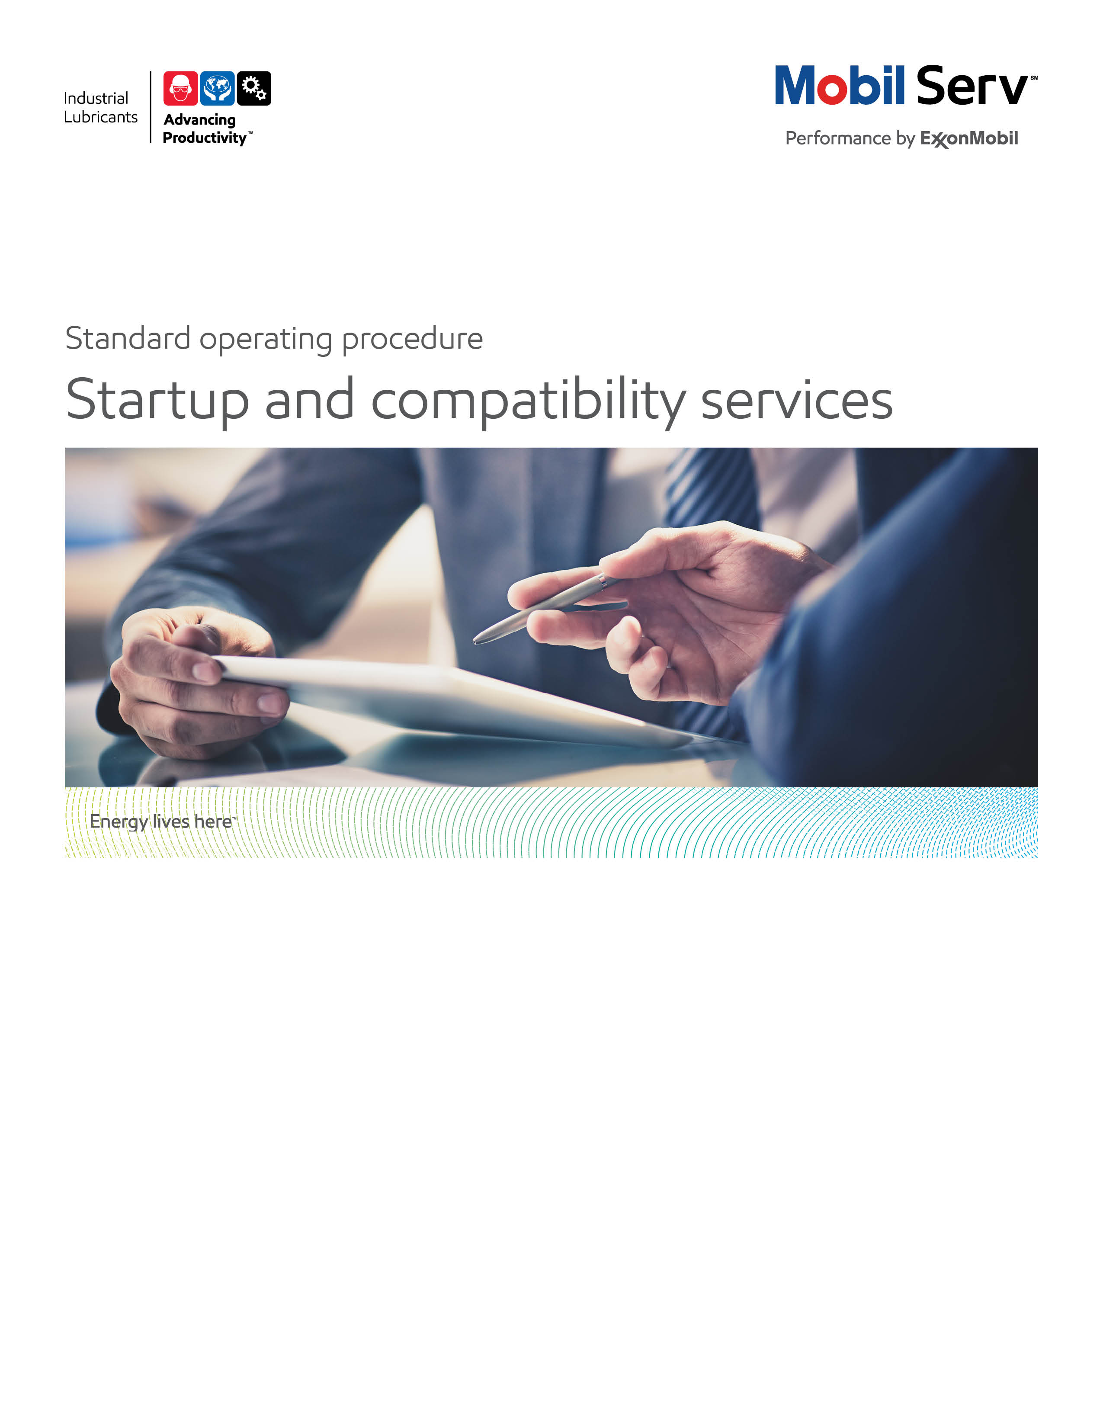
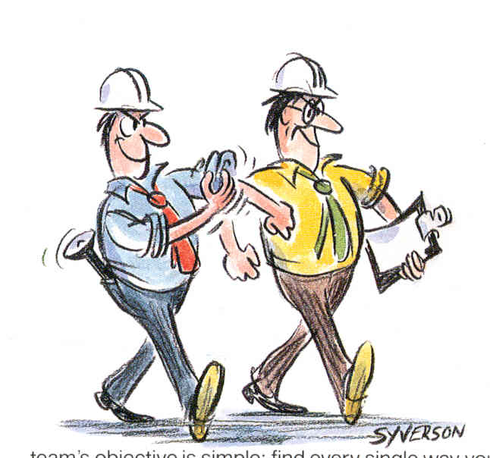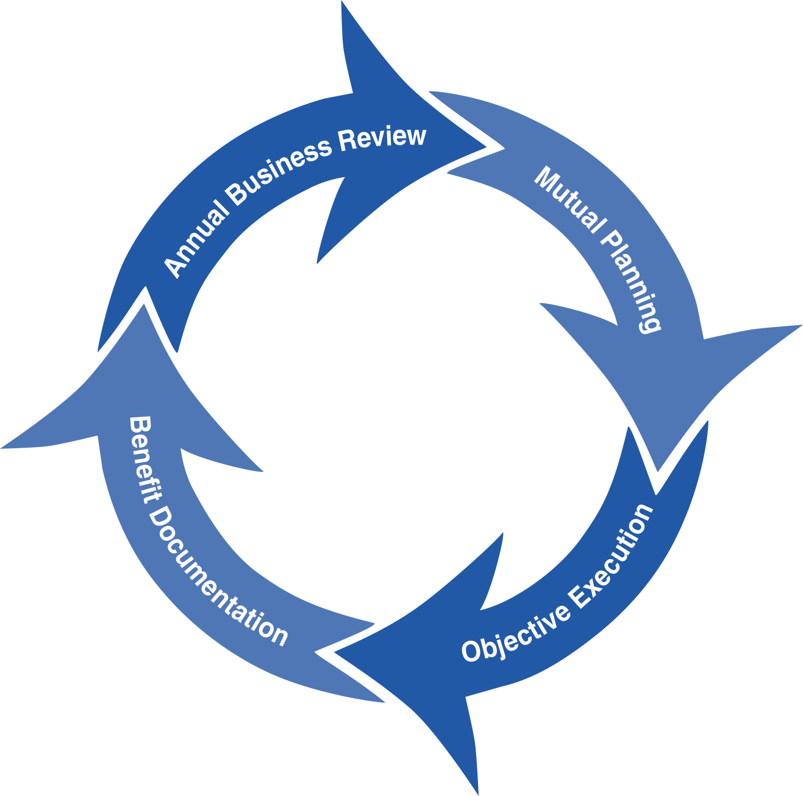
Standard Operating Procedure (SOP)
Read all of the steps in this SOP before beginning work. Follow customer labor requirements (eg respect Union work)

SOP: Start Up and Conversion to Mobil Lubricants |  | DATE  7/10/2015 |  NEW  o REVISED  ___ Number |  | PAGE 1 of 4
TYPICAL CUSTOMERS  Various: industrial Customers | WORK TYPE  Move a customer to MOBIL Products | WORK ACTIVITY (Description)  Steps to ensure a professional / trouble free conversion to MOBIL Products
DEVELOPMENT TEAM | POSITION / TITLE | REVIEWED BY/DATE |  | POSITION / TITLE
Gilles Delafargue | Global FES Advisor | Tom Schiff |  | Global FES Manager
PLEASE UTLIZE ATTACHED GENERAL JSA AS GUIDANCE AND, IF YOU HAVE DONE A SITE SPECIFIC JSA.
PLEASE ASSESS YOUR OWN CONDITIONS OR SPECIFIC SAFETY REQUIRMENTS AND BE SAFE. JSA Lube Survey General Plant
EQUIPMENT/TOOLS INDEPENDENT OF JSA DESIRED DOCUMENTATION
 LAPTOP/IPAD   LUBRICANT CALCULATORS (EHL, GREASE, ETC)   EMEBS   LOOBLE   OEM/EQUIPMENT BUILDER LITUATURE   PRODUCT DATA SHEETS   TECHNICAL HELP DESK   LUBRICANT TECHNICAL SUPPORT LAB (LINK)   LUBES GBU TECHNICAL RESOURCE LIBRARY (LINK) |  | MAKE LUBE CHART AND PROVIDE RECOMMENDATIONS AND DOCUMENTATION FOR SWITCH OVER. FOR PES ACCOUNTS MAKE PROPOSAL THAT HAS POTENTIAL TO SOLVE SUFFERING POINT/DELIVER VALUE
TIME ESTIMATED TO COMPLETE THIS TASK NUMBER OF PEOPLE TO PERFORM THIS TASK
DEPENDS ON THE SIZE OF CUSTOMER / FACTORY AND NUMBER OF RECOMMENDATIONS REQUESTED. TYPICALLY ONE RECOMMENDATION CAN RANGE FROM FIVE TO 60 MINUTES. SOME RECOMMENDATIONS MAY REQUIRE CONSULTATION WITH EB ENGINEER, BUILDER, OTHER RESOURCES OR PERFORM CALCULATIONS WHICH CAN TAKE LONGER |  | 1 CAPABLE EM OR DISTRIBUTOR PERSON  TYPICALLY THE CAPABLE PERSON (FES ENGINEER OR DISTRIBUTOR LUBRICATION ENGINEER) RECEIVING THE REQUEST MAKES THE RECOMMENDATION. THEY MAY ESCALATE TO OTHERS OR THD (TECHNICAL HELP DESK) AS NEEDED IF THEY NEED ASSISTANCE How to Obtain Technical Support
FREQUENCY TO PERFORM THIS TASK COMPETENCIES/SKLLS REQUIREED TO PERFORM THIS TASK
IT MIGHT BE A FULL SWITCH OVER FROM COMPETITION OR EXTENSION OF AN EXISTING EM CUSTOMER (AT CUSTOMER REQUEST, DISTRIBUTOR INQUIRY, ETC.) BUT CAN BE AN OBJECTIVE FOR A PES CUSTOMERS TO HELP THEM ACHIEVED IDENTIFIED BUSINESS GOALS AND/OR PROVIDE SOLUTIONS TO SUFFERING POINTS |  |  CUSTOMER EQUIPMENT / APPLICATION UNDERSTANDING AND ASSOCIATED LUBRICANTS AND LUBE APPLICATION   KNOWLEDGE FOR THOSE APPLICATIONS POINTS
 |  | TRAINING REQUIRED TO PERFORM THIS TASK
 PRODUCT KNOWLEDGE AND RECOMMENDATIONS
 EQUIPMENT APPLICATION (INCLUDING LUBE APPLICATION)
 TROUBLE SHOOTING PROBLEMS/FAILURE ANALYSIS
 EQUIPMENT INSPECTIONS
 ENGINEERING REPORT WRITING/TCO
OTHER RESOURCES REQUIRED OR SUPPORT
TECHNICAL LINKS
 Global FES Technical Resource Library/FES Toolbox (LINK)
 Lubricant Technical Support Lab Portal (LINK)

PURPOSE - This document provides guidance for capable ExxonMobil and Distributor persons to help ensure professional and trouble free conversion to MOBIL products.

External Offer Sheet: TBD

Internal Offer Sheet: TBD

LOCATION | JOB STEPS
Key Terms | - A Product Recommendation is an offer of suitability for use of an EM lubricant provided by a capable ExxonMobil or Distributor person for a client’s specific application, referencing OEM, EB requirements and/or product approvals/recommendations  - Fit to Application Evaluation is a review and an assessment of all relevant information provided by the client and collected from appropriate Information Sources about a lubricant application including OEM, EB’s specifications and industry standards, compatibility with materials in the application (seals, paint, former/current lubricant, etc.) and the client’s application operating conditions.  - Information Source is a reference used to support an appropriate product recommendation for a client’s specific application. Technical databases, EB or OEM Documentation/ eMEBS, , technical response internal tools, expert knowledge and systems supporting technical services are the main sources of information used for product recommendations. Three categories of Information Sources are defined:  - EM Standard Information can be gained from a standard system or a database or a tool approved by ExxonMobil for internal and/or external use as a technical information source or as a direct product recommendation source. EM Standard Information shall be used as a primary information source (example: eMEBS, Refrigeration Product Selector…).  - Supportive Information can be gained from appropriate sources (see Equipment/Tools Section) for product recommendation guidance. Supportive Information should be subject to capable person evaluation. Prudent measures must be taken to ensure information is truthful, accurate and definitive. If questionable, it shall not be used. (Example : POP or Benefit reports showing similar case, industry claims)  - Other References can be gained from other than above stated sources. The reference information shall be used only as a complementary source of information. Prudent measures must be taken to ensure information is truthful, accurate and definitive. If questionable, it shall not be used. (Example: Technical papers from symposium documenting similar case)  - A Switch over procedure is a document summarizing all actions / steps required to ensure trouble free conversion to MOBIL product. Some switch over procedures are general for routine applications without compatibility issues. In some cases, switch over procedures may be specific and detailed like for Refrigeration oils for example or when incompatibilities between products is known or identified. (Move from PAG to PAOs),
Request/Need for conversion to MOBIL Lubricant for a specific customer / factory | The following principles should be followed by the capable person when executing conversion to MOBIL products.  Step 1: Prepare a JSA before visiting customer/ Factory for conversion to MOBIL products.  Step 2: Conduct a “pre-conversion” visit on site to (1)list the material, units, Make/model / serial numbers with their specific local-customer designation (2)identify and list potential suffering points or customer/OEM requirements (e.g. cleanliness, flushing, etc.) identified during visit or advised by customer.(3) identify units under warranty  Step 3: Build Lubrication chart , according to following rules (1) product recommendation shall be based upon a Fit to Application Evaluation (2) Product Recommendation shall be based upon EM product specifications and claims supported by product documentation.(3)Appropriate trustable Information Sources shall be used for Product Recommendation to support proper EM product representation and meet the customer needs.(especially be extremely careful with pieces of information extracted from INTERNET, potentially uncontrolled).(4) avoid “read-across” from competitive products, which might have been wrongly selected.(5) consider rationalization of products to simplify customer product inventory  (Refer to Basic Lube Recommendation or Lube Survey SOPs)  Step 4: classify the different switch over cases within customer / OEM  - routine cases between compatible products non sensitive applications - Switch over by drain and re-fill (example: engine oils)  - sensitive application between compatible products, or move to synthetic products - switch over by drain flush & re-fill (example: move to synthetic gear oils)  - specific sensitive applications necessitating specific switch over procedure between compatible products (example: Refrigeration oils )  - Specific sensitive applications necessitating specific switch over procedure between incompatible products (example : move air compressor from PAG to PAO lubricant)  - Specific requirements such as cleanliness levels  Step 5: utilize LTS for potential compatibility studies (in addition to lubricants, consider seals, and paints). As a practice, identifying customer critical equipment (turbines, large circulation systems, central grease systems, etc.) and obtaining base line of the prior lubricant is recommended. For those systems/lubricants, running storage stability as well as appropriate performance compatibility testing is recommended.  (Note that LTS may also have prior new oil to new oil compatibility testing results on file that can be leveraged).  In many cases, comparing new oil to new oil compatibility is satisfactory but for critical systems testing the used prior lubricant to new lubricant is recommended. Please consult your Chief Engineer for guidance as needed.  Step 6: While evaluating any required cleanliness requirements, review the customer’s lubricant storage and handling as well as filtration practices – especially for their most critical equipment. Understand the “as is” implications of their practices to look for opportunities to make recommendations to improve their equipment reliability/total cost of ownership, safety and environmental impacts. Leverage the Storage and Handling as well as the Contamination Control Study SOPs.  Step 7: Provide recommendations for lubricant labeling (transfer containers, lubricant reservoirs, etc. In some cases, we may want to provide these labels. In some cases, we may help the customers install the labels.  Step 8: provide the corresponding switch over guidelines or switch over procedures per unit according to cases (1) to (4) identified above  Step 9: Provide training about Mobil SERV Used Oil Analysis programs.  (Test slates, how to make registration, how to make UOA interpretation, how to make proper sampling , importance of proper registration, sampling & labelling)  Step 10: provide training and guidelines for oil Storage and Handling procedures / Best practices  Step 11: provide labels with product names for identification of oil filling points or oil sampling points  Step 12: provide guidelines for lubricants ordering / invoicing  Step 13 build a list of all contacts at ExxonMobil (customer service, FES engineer or DLE, TM, THD, etc…) and at customer site (Tech Manager, Maintenance department, Purchasing department, etc …) detailing phone numbers and email addresses  Step 14: consider being on site for large lubricant deliveries/flushing projects to provide guidance to ensure smooth transition  Step 15: for PES customer prepare PES letter , circulate Benefit proposal, etc …  Step 16: Provide general documentation on lubricants (lube chart, PDS, SDS, general information, access to sites where customer can find information  Step 17: Provide as required on-site kits (FLOSTIC, water test kits or minilabs  Step 18: provide specific training on lubricant, lubrication and ExxonMobil process and services to ensure customer and FES engineers or DLES are aligned, and customer understand all benefits to have selected ExxonMobil as supplier.  Step 19: Plan regular visit with customer to ensure that conversion to MOBIL products is trouble free, or fix issues if any. Ensure follow up of customer and keep contact for 2 ways communications.
DOCUMENTING YOUR WORK – Product recommendations (typically for Major/PES accounts and not for routine recommendations) can be a significant way to assist customer reach their equipment reliability goals by addressing potential or actual suffering points. Persons making product recommendations should document the recommendation (technical rationale), case for action, follow up recommendations and their value using Mobil Serv Report Writer (3D) and TCO approach.

TCO is a process to quantify improved profit through the implementation of an effective lubrication program. In order to document savings involved in a partnership between the customer and Mobil Industrial Lubricants, the following categories of value-added savings will be reviewed: Revenues, Assets, Processes, and Expenditures

The TCO Worksheets are the preferred format to include in your report. Proper placement is an Appendix. Additional guidance will incorporate our messaging of TCO to include Sustainability, Safety and Productivity relationships. Quantify these costs on an annual basis. We should use customer cost/impact data. If the customer does not know the numbers then utilize estimates from experience or other resources (repair shops, OEMs, etc.) then have the customer agree to the numbers/impacts. Both Benefits and cost avoidance should be considered.

Expenditure Reduction - reduced equipment and/or lubricant purchase costs are the most typical expenditure savings. These may result from the offset of extending lube application intervals from the previous lubricant or greases against the increased price of Mobil products flagships and premium or other recommendations to modify the lubricated equipment, lubricant delivery, lubricant purification systems, etc.)

Process Improvement - the hourly wages (including burden) for personnel to perform existing tasks e.g. replaces the lubricant, or repair equipment reduced in part by the product recommendation, are typical Process improvement savings. If equipment replacements or lubricant change outs are reduced, use these to determine Process improvements. If lubricant usage is reduced, use the time to handle drums and the time to dispose of used lube to determine Process improvements.

Revenue Enhancement - any equipment failure, anticipated timely via Used Oil Analysis follow up for example, may be repaired during normal maintenance and so reduce the potential for downtime. “Unscheduled Downtime”, results in lost production and most often, scrapped parts or material. This may allow the customer to plan for a replacement during a planned outage instead of an emergency shutdown. Savings due to production losses avoided may be significant.

Asset Improvement - use the customers "cost to carry" inventories. This is used from the Expenditures components for example, if you reduce the quantity of lubricant needed, take that amount cost and multiply by the "cost to carry" to determine the Asset value.

Safety Improvement – this is typically man-hours of avoided equipment interface exposure by increasing time between lubricant application/changes, reduced equipment repairs, etc. This could also include incidents caused by slips but do not document improvements in actual number of accidents or incident rates but rather the potential to impact those statistics.

Environmental Improvement – this is typically quantified by reduced lubricant volume disposed or reduced CO2 emissions

Refer to Expenditure Reduction, Process Improvement, Revenue Enhancement, and Asset Improvement to develop TCO. The Total Cost of Ownership (TCO) Database has many equipment typical costs in it, or consults with the OEM or equipment distributor to finalize your TCO. In all cases, ensure your customer agrees with the cost estimates. Sometimes you may need to suggest an estimated cost and get the customer to agree/negotiate to acceptable figures.

TCO Database

Include any “negative” components of TCO from your recommendations (which should be rather considered as an “investment”);extra cost of lubricant first fill (synthetic Vs mineral), new lube systems, filtration, water removal, enhanced predictive monitoring, increased labor (to do the job correctly the first time), new equipment; e.g. to replace under sized equipment.

Model Reports
Conversion Benefit Documentation Steel
Conversion Proposal Air Compressor
Conversion Proposal Open Gears to Mobil SHC Gear 22/46M
Conversion Proposal for Saw Guide Oil
Conversion Proposal for Wind Turbine Gear Drive
Conversion Proposal Paper Mill Grease
Conversion Proposal Caster Grease
Conversion Plan Overview for Large Mine

ATTACHMENT:

CHECK LIST FOR CONVERSION TO MOBIL PRODUCTS

STEP 1: JSA
STEP 2: Pre-conversion visit
STEP 3: Lubrication chart
STEP 4: Evaluate Switch over procedures required
STEP 5: Compatibility studies
STEP 6: Cleanliness requirements / LTS
SPEP 7: Storage lubricants labelling
STEP 8: Provide switch over guidelines / procedures
STEP 9: MOBIL SERV Used Oil Analysis program
STEP 10: Training on Storage and Handling procedures
STEP 11: Labelling of Filling & Sampling points
STEP 12: Guidelines for Lubricant ordering / invoicing
STEP 13: List of contacts with phone & email for ExxonMobil and customer
STEP 14: Presence on site for first deliveries/important switch over
STEP 15: PES customers (letter / Benefit Proposals)
STEP 16: General documentation on Lubricants
STEP 17: On site test kits
STEP 18: Training on lubricants, lubrication and ExxonMobil process and services
STEP 19: Plan regular visits for follow up of conversion

