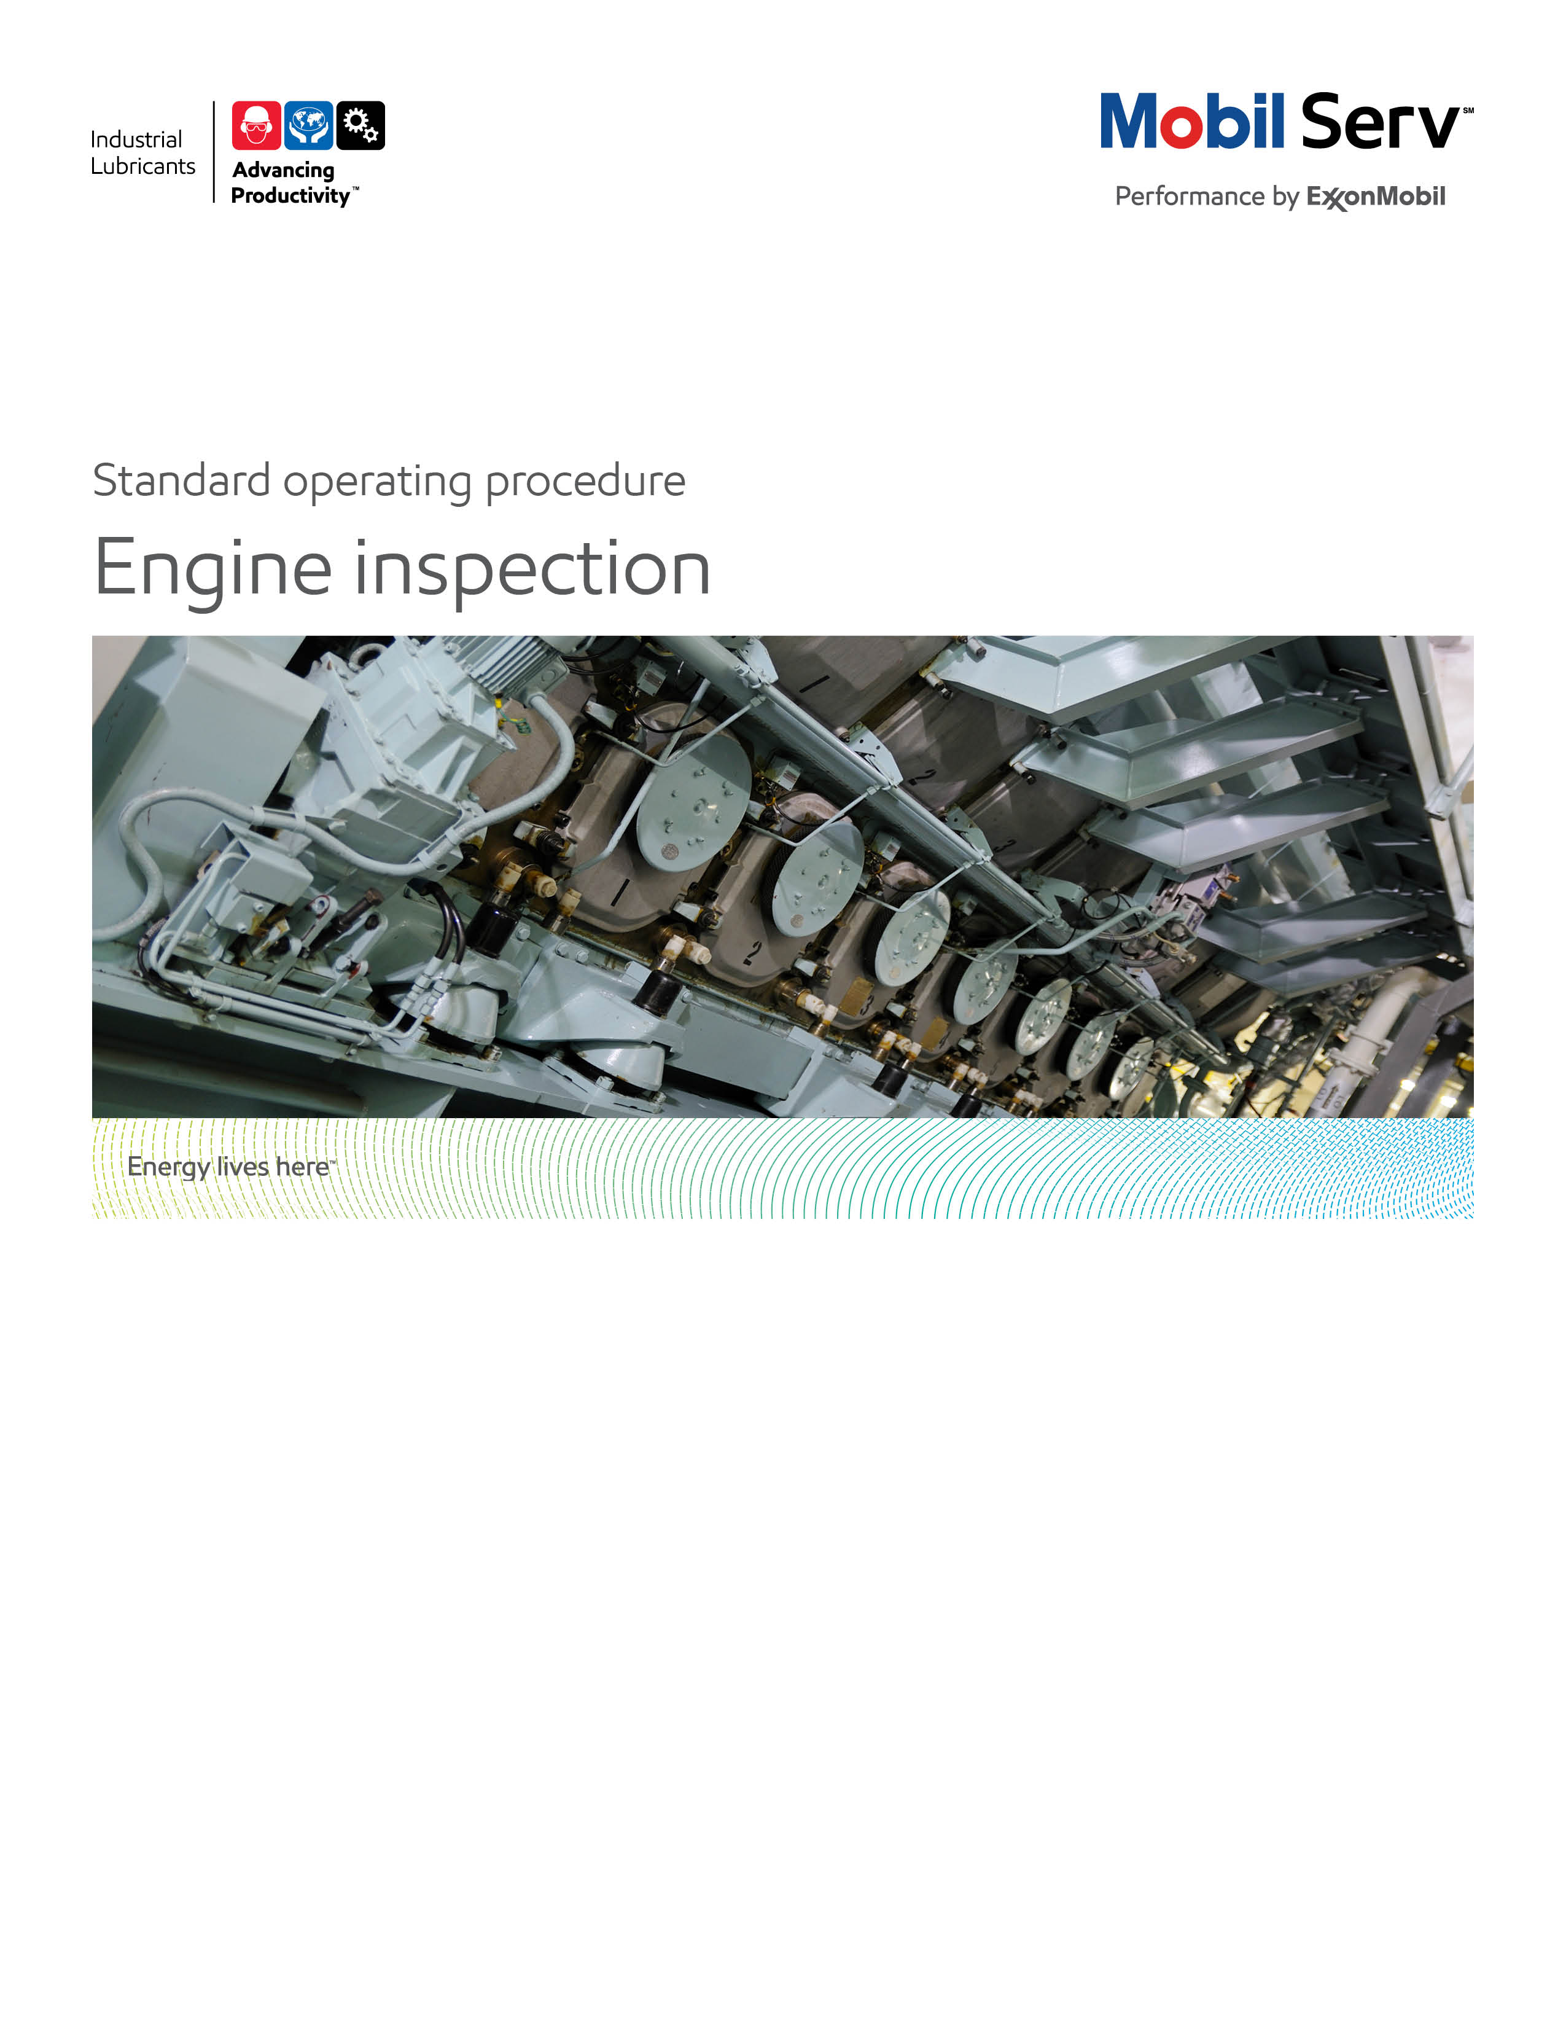


Standard Operating Procedure (SOP)
Read all of the steps in this SOP before beginning work. Follow customer labor requirements (eg respect Union work)

SOP: Borescope Inspection, Natural Gas Engines |  | DATE  4/14/2011 |  NEW  o REVISED  ___ Number |  | PAGE 1 of 3
TYPICAL CUSTOMERS  Oil & Gas, Landfill, Cogeneration facilities | WORK TYPE  Borescope Inspection | WORK ACTIVITY (Description)  Natural Gas Engine Inspection where H2S may or may not be present (Pre-cup, spark plug, valve covers, borescope Inspection).
DEVELOPMENT TEAM | POSITION / TITLE | REVIEWED BY/DATE |  | POSITION / TITLE
Glenn Thompson | Lubrication Engineer | Bill Fuller 7/26/2012 |  | FES Advisor
Gord Susinski | Lubrication Engineer | Tom Schiff 7/27/2012 |  | FES Manager
PLEASE UTLIZE ATTACHED GENERAL JSA AS GUIDANCE AND, IF YOU HAVE DONE A SITE SPECIFIC JSA.
PLEASE ASSESS YOUR OWN CONDITIONS OR SPECIFIC SAFETY REQUIRMENTS AND BE SAFE. http://intratta.na.xom.com/emdn/sbps/docs/safety/jsa/JSA_Gas_Engine_Borescope_Inspection_where_H2S_may_be_present.xls

EQUIPMENT INDEPENDENT OF JSA DESIRED DOCUMENTATION
 CLIPBOARD OR TABLET PC   BORESCOPE INSPECTION DATA COLLECTION FORMS   FLASHLIGHT   RAGS   CAMERA   BORESCOPE   BORESCOPE DUFFLE BAG - extension cords, electrical tape, Power Inverter   LOCKS WITH KEYS AND TAGS FOR LOCK-OUT/TAG-OUT   CHEATER CORD (from customer - if available)   PNEUMATIC BARRING DEVICE (from mechanical contractor)   COLLAR LENSES FOR BORESCOPE   SIDE (90°) LENS FOR BORESCOPE |  |  DAY OF - DATA GATHERING FORMS   FINAL - BORESCOPE REPORT  OTHER (SPECIFY)   BORESCOPE SERVICE DATA SHEET   PRIOR INSPECTION REPORTS   BORESCOPE INSPECTION JSA   3RD PARTY SITE ASSESSMENT REPORT   MOBIL PEGASUS 1 SAVINGS CALCULATOR (if applicable)
TIME ESTIMATED TO COMPLETE THIS TASK |  | NUMBER OF PEOPLE TO PERFORM THIS TASK
5 HOURS |  | 2
FREQUENCY TO PERFORM THIS TASK |  | SKILLS REQUIRED TO PERFORM THIS TASK
DEPENDS ON CUSTOMER COMMITMENT - Typically at time of conversion to Pegasus 1, or a new to Mobil product, to get baseline documentation of engine condition and then annually thereafter. If the inspection is a trouble-shooting exercise then it might be a one-time inspection. |  |  MECHANICAL APTITUDE   NATURAL GAS ENGINE PRINCIPLES OF OPERATION (LUBRICATION FUNDAMENTALS, 2ND EDTION, PIRRO & WESSOL, FOR REFERENCE)   DISCUSS OPERATING CONDITIONS WITH OPERATORS /  MECHANICS
JOB COMPETENCIES REQUIRED TO PERFORM THIS TASK, |  | TRAINING REQUIRED TO PERFORM THIS TASK
PRODUCT SELECTION - NATURAL GAS ENGINES OILS  OFFER EXECUTION - BASIC OFFER EXECUTION - BORESCOPE INSPECTIONS  INDUSTRIES - PETRO-CHEMICAL, LANDFILL, CO-GENERATION FACILITIES, GAS GATHERING OR TRANSMISSION - NATURAL GAS ENGINES. |  |  LMS - TDG   LMS - PVMG TRAINING   PETROLEUM SAFETY TRAINING (if required)   H2S ALIVE TRAINING (FOLLOW JSA FOR SITE SPECIFIC TRAINING)   ON THE JOB TRAINING   SITE SPECIFIC CUSTOMER ORIENTATION

PURPOSE - To describe the process of conducting a Natural Gas Engine Borescope Inspection while the equipment is shut down, with the desired reporting that provides the value back to the customer while supporting the standard Marketing Offer.

(External Offer Sheet: http://intratta.na.xom.com/emdn/sbps/technical/engg_services/Americas/Nat_Gas_Engine_Inspection.pdf)

(Internal Offer Sheet: Place holder when available)
LOCATION | JOB STEPS
Gas Engine site (before borescope inspection takes place) | - Notify operators / mechanics that you are on site.  - Review XOM JSA with site personnel.  - Complete a 3rd party site safety checklist with facility operators prior to beginning work  - Complete any necessary site-specific orientation required - (determine locations of exit routes, muster points, eyewash stations, wind socks).  - Complete a hot work permit and review it with operators and mechanics prior to starting work (if applicable)  - Allow time for the operator to shut down the engine and for the mechanics to remove valve covers (if necessary), spark plug carriers, ignition sensors, and pre-cups. In addition, the mechanics will install a pneumatic barring (describe this please) device if available. By this time, the engine will have cooled down enough to be able to start the borescope inspection.  - Survey the engine area room for safety hazards  - Ensure that you have the equipment required and documentation / data collection templates prior to beginning work  - Determine location of power supply for the borescope.  If cheater cord available, plug in borescope extension cord and tape up the connection with black electrical tape.  If the use of a power inverter connected to a vehicle battery is required, refer to the JSA for instructions on how to connect the inverter safely. Turn on the inverter and ensure that it outputting the correct power level. Connect the borescope extension cord and tape up the connections with black electrical tape. (see photos)  - Turn on the borescope  - Insert memory card into drive A:  - Using menu selections set the borescope to save the photographs to drive C: and label file as site specific (i.e. customer name or specific location).  - Obtain the engine operations log book for pertinent engine operation information and record on the data gathering sheet  - Prior to starting the inspection, ensure that you are aware of the work that other personnel in the area are doing (i.e. mechanics, operators etc.).  - Prior to barring the engine over ensure that everyone is aware that the engine will be turning over (simply done by yelling "barring" and ensuring that anyone working on or around the engine acknowledges).  - If barring manually, determine the firing order. This will make it easier to determine which cylinders have vales open at the same time. This will save time and reduce the number of times you will need to bar the engine over.
Gas Engine Borescope Inspection | Visually inspect system (use the Collar attachment) and take photos of and record photo numbers and ratings on the data collection worksheet for each of the following areas:  - Valve deck: Observe the valves in the seated position to look for signs of recession/torching, cracks in head, glycol leaks, cleanliness or signs of varnish.  - Liner Top: look for signs of metal wiping at the interface between the head and the liner (combustion chamber)  - Liner Middle: look for signs of liner scoring and indicate whether the cross hatch is present or missing. Record position of scoring/scuffing/mirror polish (i.e. 3 O'clock position).  - Liner Bottom: look for signs of liner scoring at the piston crown and indicate whether the cross hatch is present or missing and try to determine if the source is from the piston  - Piston: circle the piston top edge and look for evidence of piston detonation and or ash pounding on the edge of the piston. Record the position of detonation or ash pounding damage (i.e. at 3 O'clock position).  Visually inspect system (use the 90° attachment). Take photos of and record photo numbers and ratings on the data collection worksheet for each of the following areas:  - Exhaust valves (in open position) for evidence of valve recession  - Intake valves (in open position) for evidence of valve recession  - Amount of deposits in the tulip area of the valves  Over all look at the amount of and consistency of the ash in the engine
Gas Engine site (after borescope inspection takes place) | - Using menu selections set the borescope to copy the photograph file to drive A (memory card  - Power down all associated equipment  - Remove power inverter from vehicle battery by removing the clip from the +ve terminal and the -ve remote ground terminal.  - Notify operators / mechanics that you have completed the assessment.  - Request fire eyes be turned on  - Survey the engine area room for your material and clean up  - Remove locks on the fuel gas valve on the engine  - Sign off the hot work permit with the site operator and let them know you are leaving the site.  - Follow all road rules and speed limits when exiting the site.
Feedback about this SOP - Send to Field Engineering Advisor/Supervisor

DOCUMENTING YOUR WORK - The Natural Gas Engine Borescope Inspection is used to verify the performance of Mobil premium and flagship gas engines oil. Three files are the backbone to producing the Engineering Service Report and go as appendices.
- The Borescope Data Summary Workbook.xls is used to record findings during the inspection. It can be useful in preparing an Engineering Service Notice for any immediate notification items for the customer.
- The Borescope Finding and Photo Generator.dot.docx generates a word document that contains all of the information inputted into the Borescope data Summary Workbook as well as formats the photos into the word document so that you do not have to copy and paste the photos individually. It was developed to save hours of time in writing the report. Follow the instructions about selecting a folder to capture the photos while conducting the borescope inspection while filling out the Borescope Data Summary Workbook.
- TCO calculations that apply (see section below)

The Engineering Service Report using 3D Writer, is to be used to document the final Borescope
Inspection. Take the findings from the (Borescope.dot) file and document the Highlights, Discussion and
Conclusions like any ESR.

TCO calculations that may apply are Expenditures Reduction, Process Improvement, and Revenue
Enhancement and Asset Improvement as detailed below. The TCO Worksheets are the preferred format
to include in your report. Additional guidance will incorporate our messaging of TCO to include
Sustainability, Safety and Productivity relationships.

Expenditure Reduction - reduced lubricant purchase costs are the most typical expenditure savings. These only result from the offset of extending lube application intervals from the previous lube against the increased price of Mobil premium and flagship products. Expenditures could also be the cost of head replacement (Waukesha Head Replacement $3K, Cat 3600 head $3.5K, Wartsila 34SG head $16K,), reduction of overhaul frequency (large bore overhaul $100K). This may allow the customer to plan for a replacement during a planned outage instead of an emergency shutdown. A third expenditure may come from disposal costs of used engine oil. Find out how much the unit cost of disposal is and use the consumption on an annual basis. Make sure to factor in the reduced usage with Mobil premium and flagship products as they apply or have applied in time. In addition, fuel-gas usage should be less when using synthetic ngeo. Test data has shown that Pegasus SHC can reduce fuel-gas usage by about 1.5% versus conventional natural gas engine oil.

Process Improvement - the hourly wages (including burden) for personnel to perform existing tasks. If head swings or lubricant change outs are reduced, use these to determine Process improvements. If lubricant usage is reduced, use the time to handle drums and the time to dispose of used lube to determine Process improvements.

Revenue Enhancement - any serious abnormal engine system or lubricant condition observed may be repaired during normal maintenance and reduce the potential for downtime. “Unscheduled Downtime”, resulting in lost production and most often, scrapped parts or material. Waukesha and compressor down for 1 day average $48K

Asset Improvement - use the customers "cost to carry" (usually 20%) inventories. This is used from the Expenditures components for example, if you reduce the quantity of lube needed, take that amount cost and multiply by the "cost to carry" to determine the Asset value.

Refer to Expenditure Reduction, Process Improvement, Revenue Enhancement, Asset Improvement and TCO Summary Worksheet.xls.

Documentation Links:

TCO Worksheets http://intratta.na.xom.com/emdn/sbps/technical/ROAR/TCO_Worksheets.html

Borescope Data Summary Workbook http://intratta.na.xom.com/emdn/sbps/technical/engg_services/SOP/Borescope%20Data%20Summary%20Workbook.xls

Borescope Finding and Photo Generator http://intratta.na.xom.com/emdn/sbps/technical/engg_services/SOP/Borescope%20Finding%20and%20Photo%20Generator.dot

Example Engineering Service Report -
Error! Hyperlink reference not valid. http://intratta.na.xom.com/emdn/sbps/technical/engg_services/SOP/Engineering%20Service%20Report%20Borescope%20The%20City%20of%20Medicine%20Hat%20August%202011%20Final%201.pdf

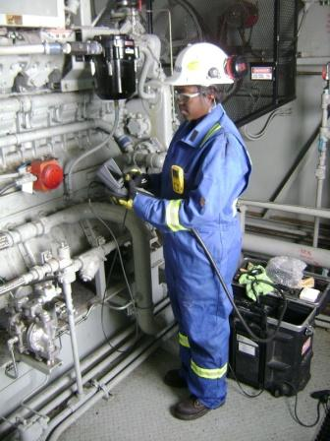
PPE:
- Hard Hat
- Hearing Protection
- Eye Protection
- Nomex Cover-alls with reflective stripes
- Gloves
- Steel toed boots
- 4 -head gas monitor

Safety: Wearing proper PPE

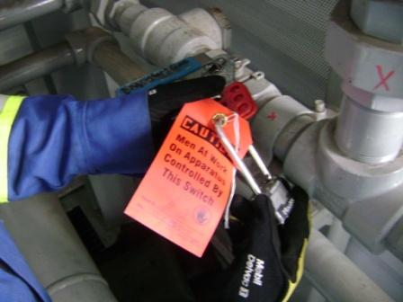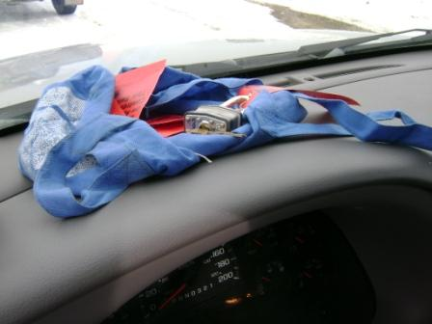
Safety: Locking out fuel gas supply
Best Practice: extra locks/bags on dash so you do not forget to remove your lock before leaving site

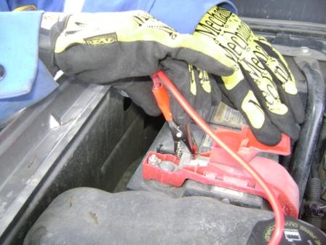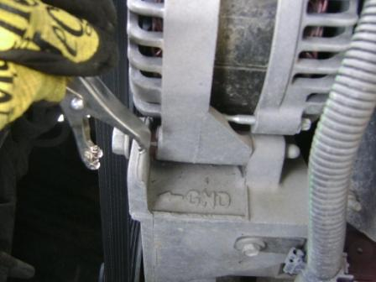
GND

Connecting power inverter red +ve cable to +ve battery terminal.
Connecting inverter black -ve cable to ground terminal on vehicle engine.

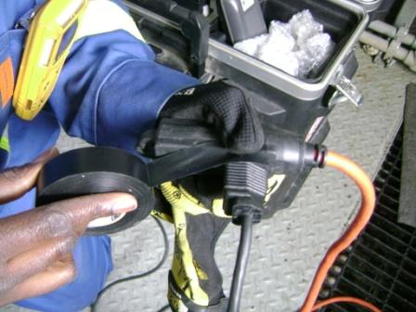

Taping extension cord connections.

EXAMPLES OF TYPES OF PHOTOS TO TAKE

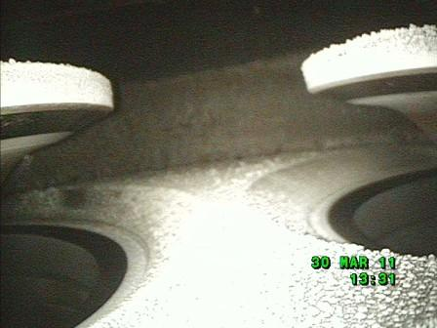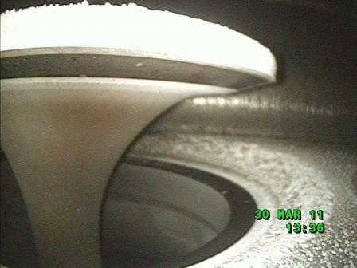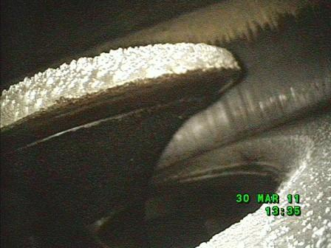

EXHAUST VALVES EXHAUST VALVE INTAKE VALVE

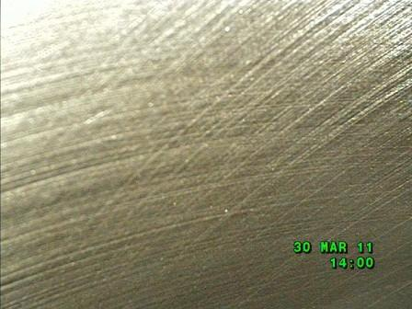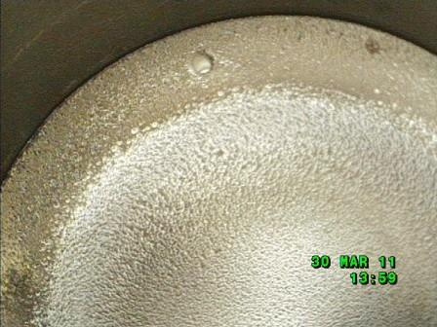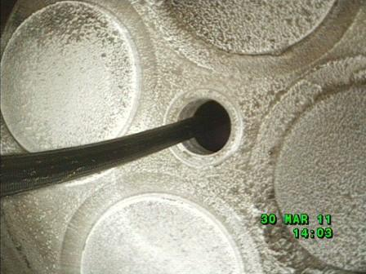

LINER TOP OF PISTON VALVE DECK (HEAD)

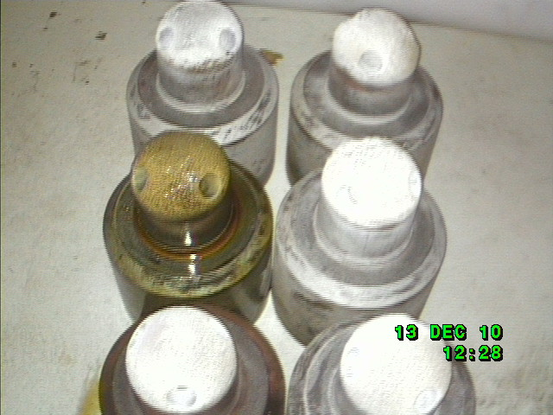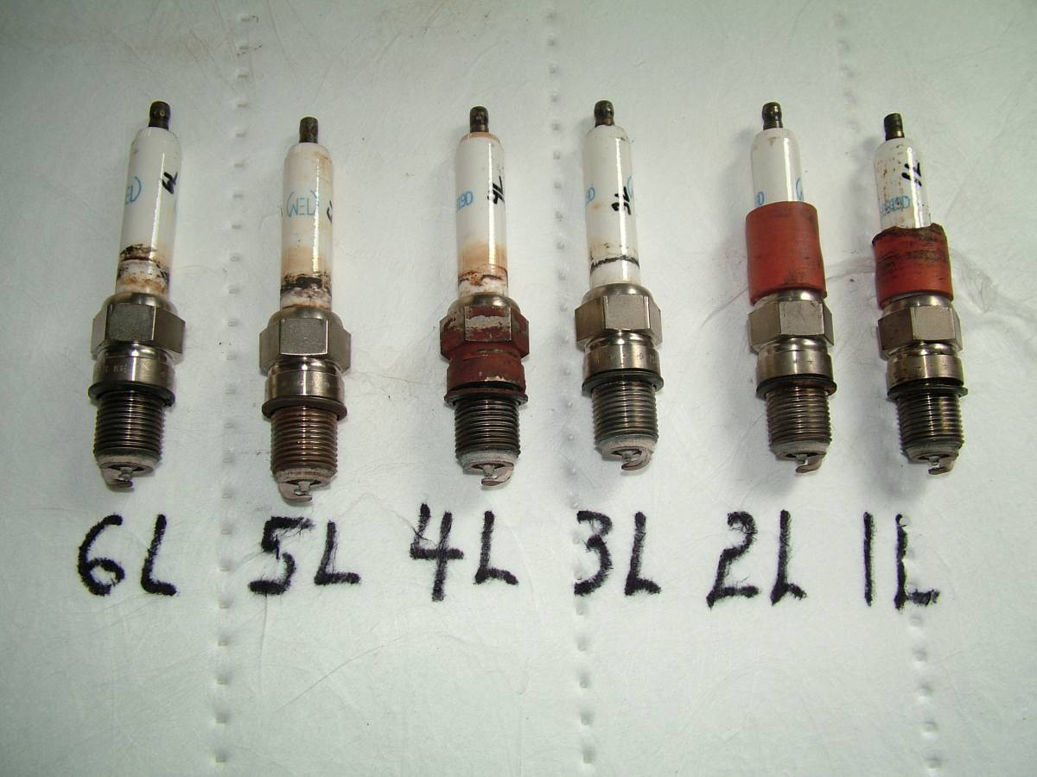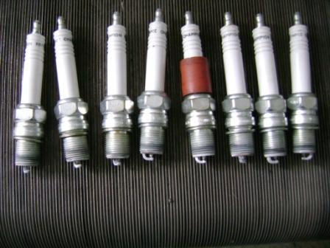

PRE-CUPS SPARK PLUGS SPARK PLUGS

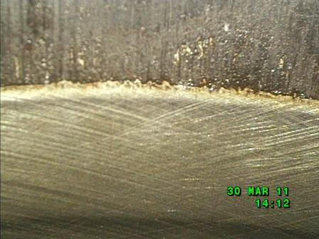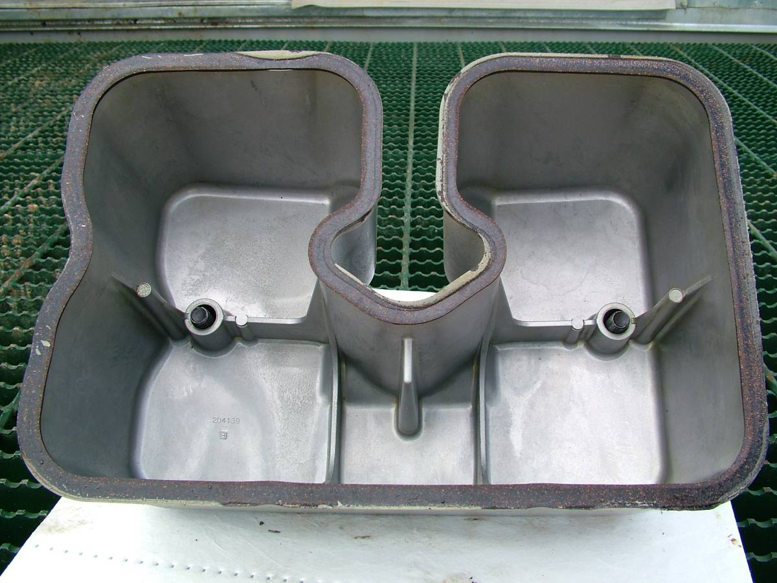

TOP OF LINER VALVE COVER

