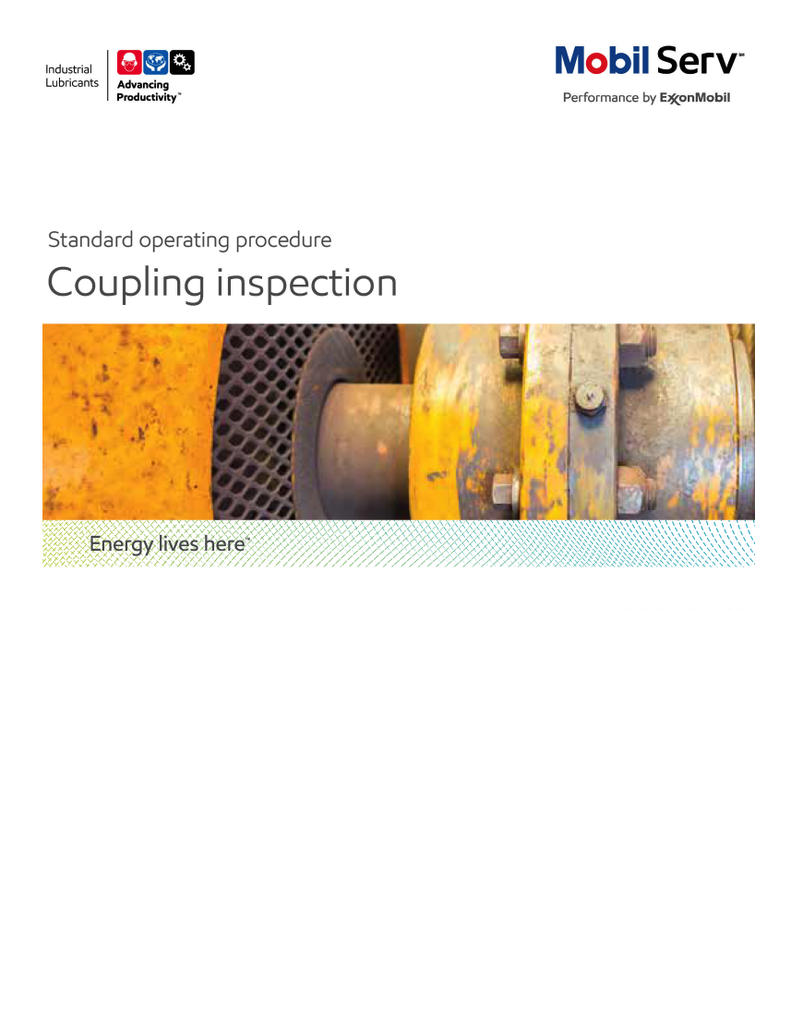

 

**Standard Operating Procedure** **(SOP)**

**Read all of the steps in this SOP before beginning work.** **Follow customer labor requirements (i.e. respect Union work)**

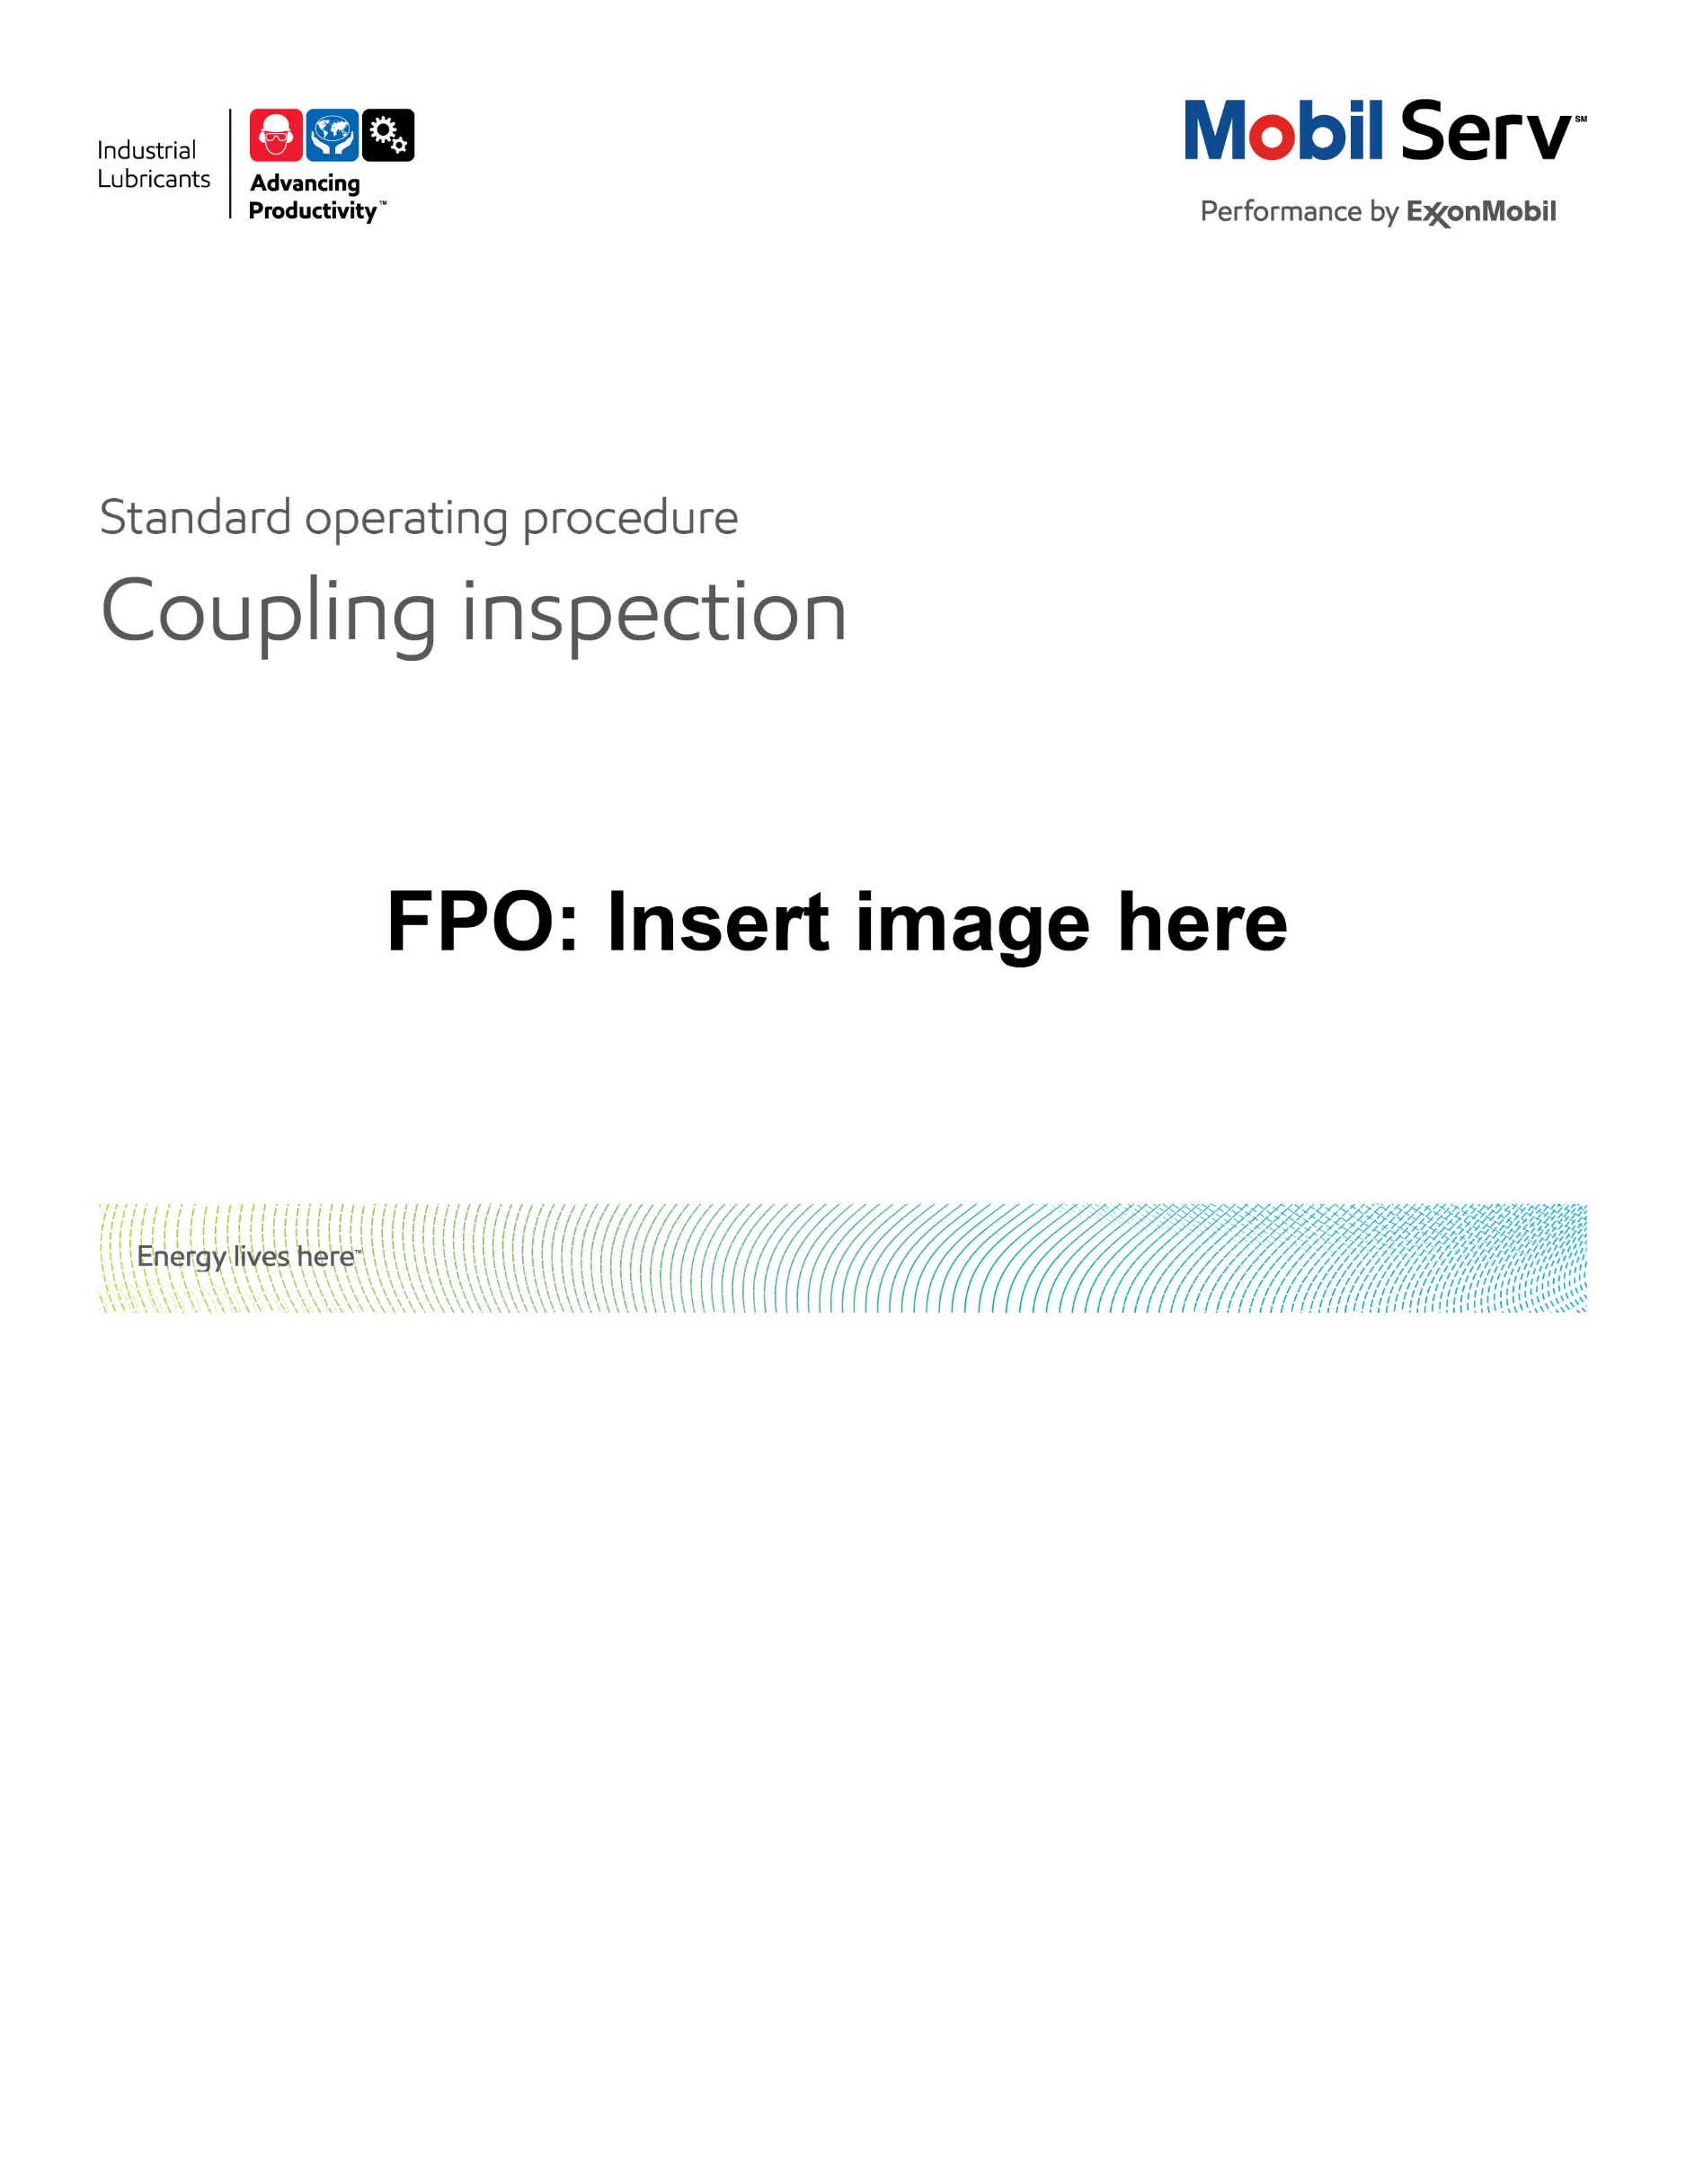

|  |  |  |  |  |  |
| --- | --- | --- | --- | --- | --- |
| **SOP: COUPLING INSPECTION** | | DATE  11/15/2013 | ⌧ NEW  REVISED  ___ Number | | PAGE 1 of 7 |
| TYPICAL CUSTOMERS  Steel, Paper & GM | WORK TYPE  Flexible Coupling | WORK ACTIVITY (Description)  Steps to perform coupling inspections for customers | | | |
| **DEVELOPMENT TEAM** | **POSITION / TITLE** | **REVIEWED BY/DATE** | | **POSITION / TITLE** | |
| Lucas Kerley | US East LE | Tom Schiff Aug 28, 2014 | | Global FES Manager | |
| Eric Brace | US West LE |  | |  | |
|  |  |  | |  | |
| **PLEASE UTLIZE ATTACHED GENERAL JSA AS GUIDANCE OR IF APPLICABLE CONSULT YOUR SITE SPECIFIC JSA.**  **PLEASE ASSESS YOUR OWN CONDITIONS OR SPECIFIC SAFETY REQUIREMENTS AND BE SAFE.**  [**http://intratta.na.xom.com/emdn/sbps/docs/safety/jsa/JSA_Coupling_Inspection_Paper_Mill.xls**](http://intratta.na.xom.com/emdn/sbps/docs/safety/jsa/JSA_Coupling_Inspection_Paper_Mill.xls) | | | | | |
| **EQUIPMENT INDEPENDENT OF JSA DESIRED DOCUMENTATION** | | | | | |
| ⌧ COMPUTER  ⌧ MASK  ⌧ FLASHLIGHT  ⌧ RULER TO MEASURE COUPLING GAP  ⌧ SAMPLE THIEF, BOTTLES & LABELS (OIL LUBRICATED)  ⌧ RAGS  ⌧ CAMERA (Check if customer approval needed)  ⌧ LOCKS WITH KEYS AND TAGS FOR LOCK-OUT/TAG-OUT | | ⌧ DAY OF - COUPLING INSPECTION CHECKLIST  ⌧ PROTOCOL FOR COUPLING RECOMMENDATION  ⌧ FINAL - ESR WITH TCO SAVINGS  **OTHER (SPECIFY**)  ⌧ PRIOR INSPECTION REPORTS  ⌧ 3RD PARTY SITE ASSESSMENT REPORT | | | |
| **TIME ESTIMATED TO COMPLETE THIS TASK** **NUMBER OF PEOPLE TO PERFORM THIS TASK** | | | | | |
| ½ day planning for work  ½ to full day conducting inspections  ½ day to write report | | 1 - 2, SHOULD CONSIDER CUSTOMER PERSONNEL | | | |
| **FREQUENCY TO PERFORM THIS TASK** **SKLLS REQUIREED TO PERFORM THIS TASK** | | | | | |
| Typically done as part of a service to troubleshoot less than desired coupling life – advanced problem solving or can be part of a coupling lubrication program assessment | | ⌧ MECHANICAL APPTITUDE,  ⌧ LUBRICANT KNOWLEDGE  ⌧ COUPLING KNOWLEDGE  ⌧ FIELD CONDITIONS INTERPRETATIONS  ⌧ GREASE APPLICATION  ⌧ COUPLING CATALOG  ⌧ COUPLING PART INSPECTION  ⌧ FAILURE ANALYSIS  ⌧ UOA INTERPRETATION SKILLS; | | | |
| **JOB COMPETANCIES REQUIRED TO PERFORM THIS TASK,** | | **TRAINING REQUIRED TO PERFORM THIS TASK** | | | |
| PRODUCT SELECTION – COUPLING APPLICATION.  OFFER EXECUTION - BASIC OFFER EXECTUION – COUPLING INSPECTIONS | | ⌧ Coupling training eLearn on lms  ⌧ Witnessing/conducting a gear/grid coupling inspection  ⌧ Product knowledge and Recommendations  ⌧ Equipment Application (coupling)  ⌧ Trouble shooting problems/Failure Analysis  ⌧ Site specific safety training | | | |
| **OTHER POSSIBLE RESOURCES REQUIRED OR SUPPORT** | |  | | | |
| ⌧ www.mobilindustrial.com  ⌧ INSIDE SALES – Technical Resoruces | | ⌧ LTS (LUBRICANT TECHNICAL SUPPORT)  ⌧ VDR (Check Other Coupling Service Reports) | | | |

**PURPOSE -** Describe the process of conducting a flexible coupling inspection while the equipment is shut down, with the desired reporting that provides value back to the customer while supporting the standard Marketing Offer.

External Offer Sheet: N/A

Internal Resources: [Inside Sales - Technical Resources - Product Applications](http://ishareteam2.na.xom.com/sites/LSSG031/TechResources/Tech%20Resources%20Docs/Forms/Product%20Applications.aspx?PageView=Shared&InitialTabId=Ribbon.WebPartPage&VisibilityContext=WSSWebPartPage) see couplings

[Coupling Inspection Check List](http://ishareteam2.na.xom.com/sites/LSSG031/TechResources/Tech%20Resources%20Docs/Coupling%20Inspection%20Check%20sheet.doc)

[Gear coupling Inspection Video](http://ishareteam2.na.xom.com/sites/LSSG031/TechResources/Tech%20Resources%20Docs/Gear%20Coupling%20Inspection%20Video.mpg)

**INTRODUCTION**

Select coupling inspections can help customers prevent equipment failure, which, may result in reduced periods of downtime, rebuild costs and many hours of lost sleep of plant engineers. A single coupling failure on a critical piece of equipment can cost tens of thousands of dollars. A plant can have a large number of couplings so these inspections should be focused toward certain units with a goal in mind. For example …

* Couplings with a history of equipment reliability issues where the inspection can aid in understanding the root cause
* Assessing the coupling lubrication effectiveness
* Training customer personnel on proper coupling lubrication practices

**PROCEDURE**

1. **Prior to the coupling inspection**
   1. Understand value of inspection to you customer
      * Improved productivity
      * Reduced coupling repairs
   2. Notify customer of your arrival and meet to review the day’s activity
   3. Follow site safety requirements and discuss potential inspection hazards
      * Complete any site safety orientation
      * [Coupling Inspection JSA](http://intratta.na.xom.com/emdn/sbps/docs/safety/jsa/JSA_Coupling_Inspection_Paper_Mill.xls)
      * [3rd Party Site Safety Checklist](http://intratta.na.xom.com/emdn/sbps/safety/third_party_site_safety.html)
   4. Ensure all documents and tools are ready to begin coupling inspection
      * LOTO and PPE
      * Camera memory card, batteries, and customer approval if needed
      * Flashlight batteries
      * Gloves and rags/towels
      * Coupling Inspection Form
   5. Obtain coupling data and equipment maintenance history for units to be inspected
      * Make, Model, RPM, Operating Temperature
      * Previous coupling inspection reports and lubrication history
   6. Reference OEM documentation
      * Rexnord: [Coupling Literature](http://www.rexnord.com/sites/process/TechLibrary/Pages/InfoLibrarySearchPage.aspx?Group=Couplings)
      * Lovejoy: [Coupling Literature](http://www.lovejoy-inc.com/resources/installation-instructions.aspx)
      * Kop-Flex (Emerson Industrial Automation): [Coupling Literature](http://www.emersonindustrial.com/en-US/powertransmissionsolutions/documentsearch/Pages/document-search.aspx)
2. **Performing the coupling inspection (customer will disassemble)**
   1. Follow proper Safety Steps (Lock Out, PPE, JSA, SPSA)
   2. Utilize Coupling Inspection Check List [Coupling Inspection Check List](http://ishareteam2.na.xom.com/sites/LSSG031/TechResources/Tech%20Resources%20Docs/Coupling%20Inspection%20Check%20sheet.doc)
   3. Remove coupling guards and check interior for lubricant flung out onto coupling guard interior
   4. Before disassembly, check coupling bolts for looseness and note whether grease plugs or grease fitting were installed on the cover or sleeve
   5. This procedure will focus on lubricated flexible couplings of the gear and grid type. However the inspection process can be applied to other types.

GEAR 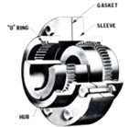 GRID 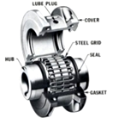 CHAIN 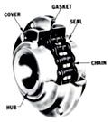

* 1. Upon removing the cover
     + Check grease condition – is it soft, uncontaminated, and sufficiently covering the full circumference of the coupling? (example of good condition below)
     + What is the current re-greasing interval?
     + Does any dust or particulate fall out when removing the shell?
     + What is the condition of the seals and gaskets?

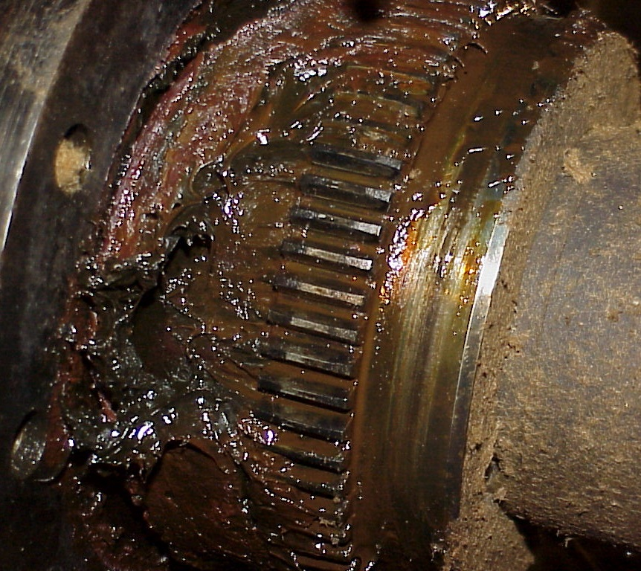

* 1. Wipe off grease to examine teeth
     + Document wear pattern and severity

|  |  |
| --- | --- |
| **GEAR** | **GRID** |
| Concentrated non-tapered wear could indicate poor teeth engagement/hub spacing - Verify the correct gap between the hubs  - 100% of hub teeth should be engaged | Inspect the grid for wear, especially across the flat faces, and in the turns. Presence of breaks or cracks in the grid element indicates high shock loading. |
| Tapered wear can indicate misalignment | Check wear on the hub teeth and if any broke off |

* 1. Record any components that are replaced

1. **After the coupling inspection (customer re-assembles)**
   1. Properly hand pack the coupling hub and cover teeth with fresh grease
   2. Properly assemble the coupling (keyways should be 180° apart, use OEM bolt torque specs)
   3. Properly purge the coupling with fresh grease
      * Remove both cover grease plugs
      * Insert a grease fitting in one hole and apply grease slowly until grease expels from the open hole
      * Remove grease fitting and insert the fitting in the other open hole and apply grease slowly until grease expels from the open hole
      * Remove the grease fitting and put both grease plugs back into the covers.
   4. Replace coupling guard and clean up area of tools, parts, and grease
   5. Remove lock out locks and notify operations
2. **Notify maintenance personnel of any immediate actions before departing site.**
3. **Document inspection and value back to customer. See internal example links below.**
   1. [**Coupling Inspection 1**](http://ishareteam3.na.xom.com/sites/LSSG035/VDR%20Document/IP%20Coupling%20Inspection%20support%20-073013.pdf)
   2. [**Coupling Inspection 2**](http://emgs.dct.na.xom.com/ls_roar/industrial/1-816-1520/2010/gp_bi_2010_coupling_root_cause_investigation_binder.pdf)

**COUPLING LUBRICATION**

Gear, grid, chain, and fluid type flexible couplings have metallic surfaces that slide and pivot against each other, thus requiring lubrication to prevent wear. Coupling lubricants must be very viscous to withstand high loads induced over small contact areas. Grease is usually the lubricant of choice with gear, grid, and chain couplings; oil is the typical lubricant for the fluid coupling (torque converter).

Grease is a preferred lubricant, due to the ease of application and the ability to keep it in the assembly. It is the centrifugal action of the rotating coupling that forces the grease to the outer circumference of the inner cavity where it can be re-engaged between the teeth to form an oil wedge and prevent wear.

The centrifugal gravitational forces that enable the grease to remain effective can also act as an enemy. Grease is a thickener which holds oil in suspension. Most general purpose greases contain thickeners that have a higher density than oil, which causes the thickener to separate from the oil and accumulate in the tooth mesh area. The lubricating oil accumulates in the center of the coupling where it serves no useful purpose. This condition can cause high coupling wear and failure so high speed coupling grease must be built to resist centrifugal separation.

Conversely, if the coupling is turning too slow and not forcing the grease to the outer circumference of the inner cavity, the teeth will not have a sufficient supply of lubrication. The result is also high coupling wear and failure. This condition can be remedied by using a more fluid grease or high viscosity gear oil. A more fluid lubricant will be able to move into the load zone between the sliding and pivoting gear teeth without the aid of centrifugal forces.

Flexible couplings that employ metallic surfaces that slide and pivot will have a short life and contribute to unexpected downtime if they are not properly maintained.

Proper coupling maintenance includes:

* Selecting the proper coupling for the application,
* Installing the coupling with minimal misalignment,
* Conducting frequent external inspections for leaks, missing or loose bolts, vibration, and the need for periodic realignment,
* Re-lubrication and internal inspections, and
* Checking that the coupling maintains a proper level of lubricant throughout the specified re-lubrication period.

**BASELINE DATA**

Obtain and record following data:

* d, shaft diameter(mm)
* T, torque (Nm)
* rpm, Rotation Speed (rpm)
* Max Tem, Maximum Coupling Surface Temperature (ºC)
* Misalignment (degrees)



**GREASE LUBRICATED COUPLING WORKING CONDITION CLASSIFICATION**



**COUPLING WORKING CONDITON JUDGEMENT PROCESS**

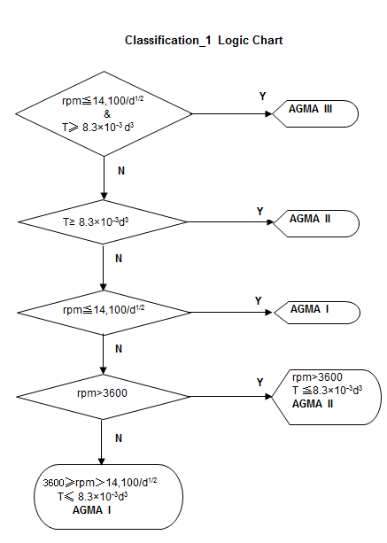

**COUPLING GREASES SPECIFICATION**

* **AGMA CG-1**
* **AGMA CG-2**
* **AGMA CG-3**



**PROUDUCT RECOMMENDATION**

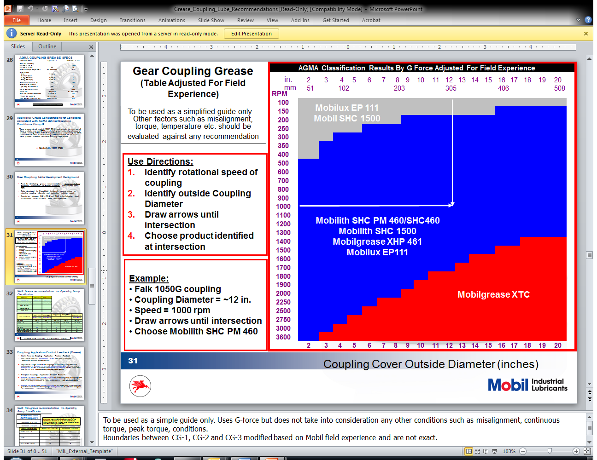

For warranty purposes, the AGMA approved ExxonMobil greases are listed below.

|  |  |  |
| --- | --- | --- |
| **AGMA CG-1** | **AGMA CG-2** | **AGMA CG-3** |
| Mobilgrease XTC | Mobilgrease XTC | Mobilux EP 111 |
| Mobilux EP 111 |  |  |

**REGREASE INTERVAL**

The following re-lubrication interval is recommended for grease lubricated flexible couplings:

|  |  |
| --- | --- |
| Operating Temperature °C (°F) | Actual Operating Time |
| 65°C (150°F) | 8,000 hours or 1 year |
| 90°C (200°F) | 4,000 hours or 6 months |
| 120°C (250°F) | 1,500 hours or 2 months |
| 150°C (300°F) | 200 hours or 7 days |

Re-lubrication intervals should never be less than once per calendar year - even for couplings in intermittent service.

**SOURCE**

AGMA 9001-B97 Document Information, Flexible Couplings-Lubrication, Jan 1, 1997

Lubrication Fundamentals, D.M.Pirro & A.A.Wessol, 2001

Coupling Grease Lubrication Explained TC 04-01, Maurice Dionne, Jan 2004

Why Choose Falk Steelflex Couplings?, Rexnord, JAN 2012

GEAR  GRID  CHAIN 