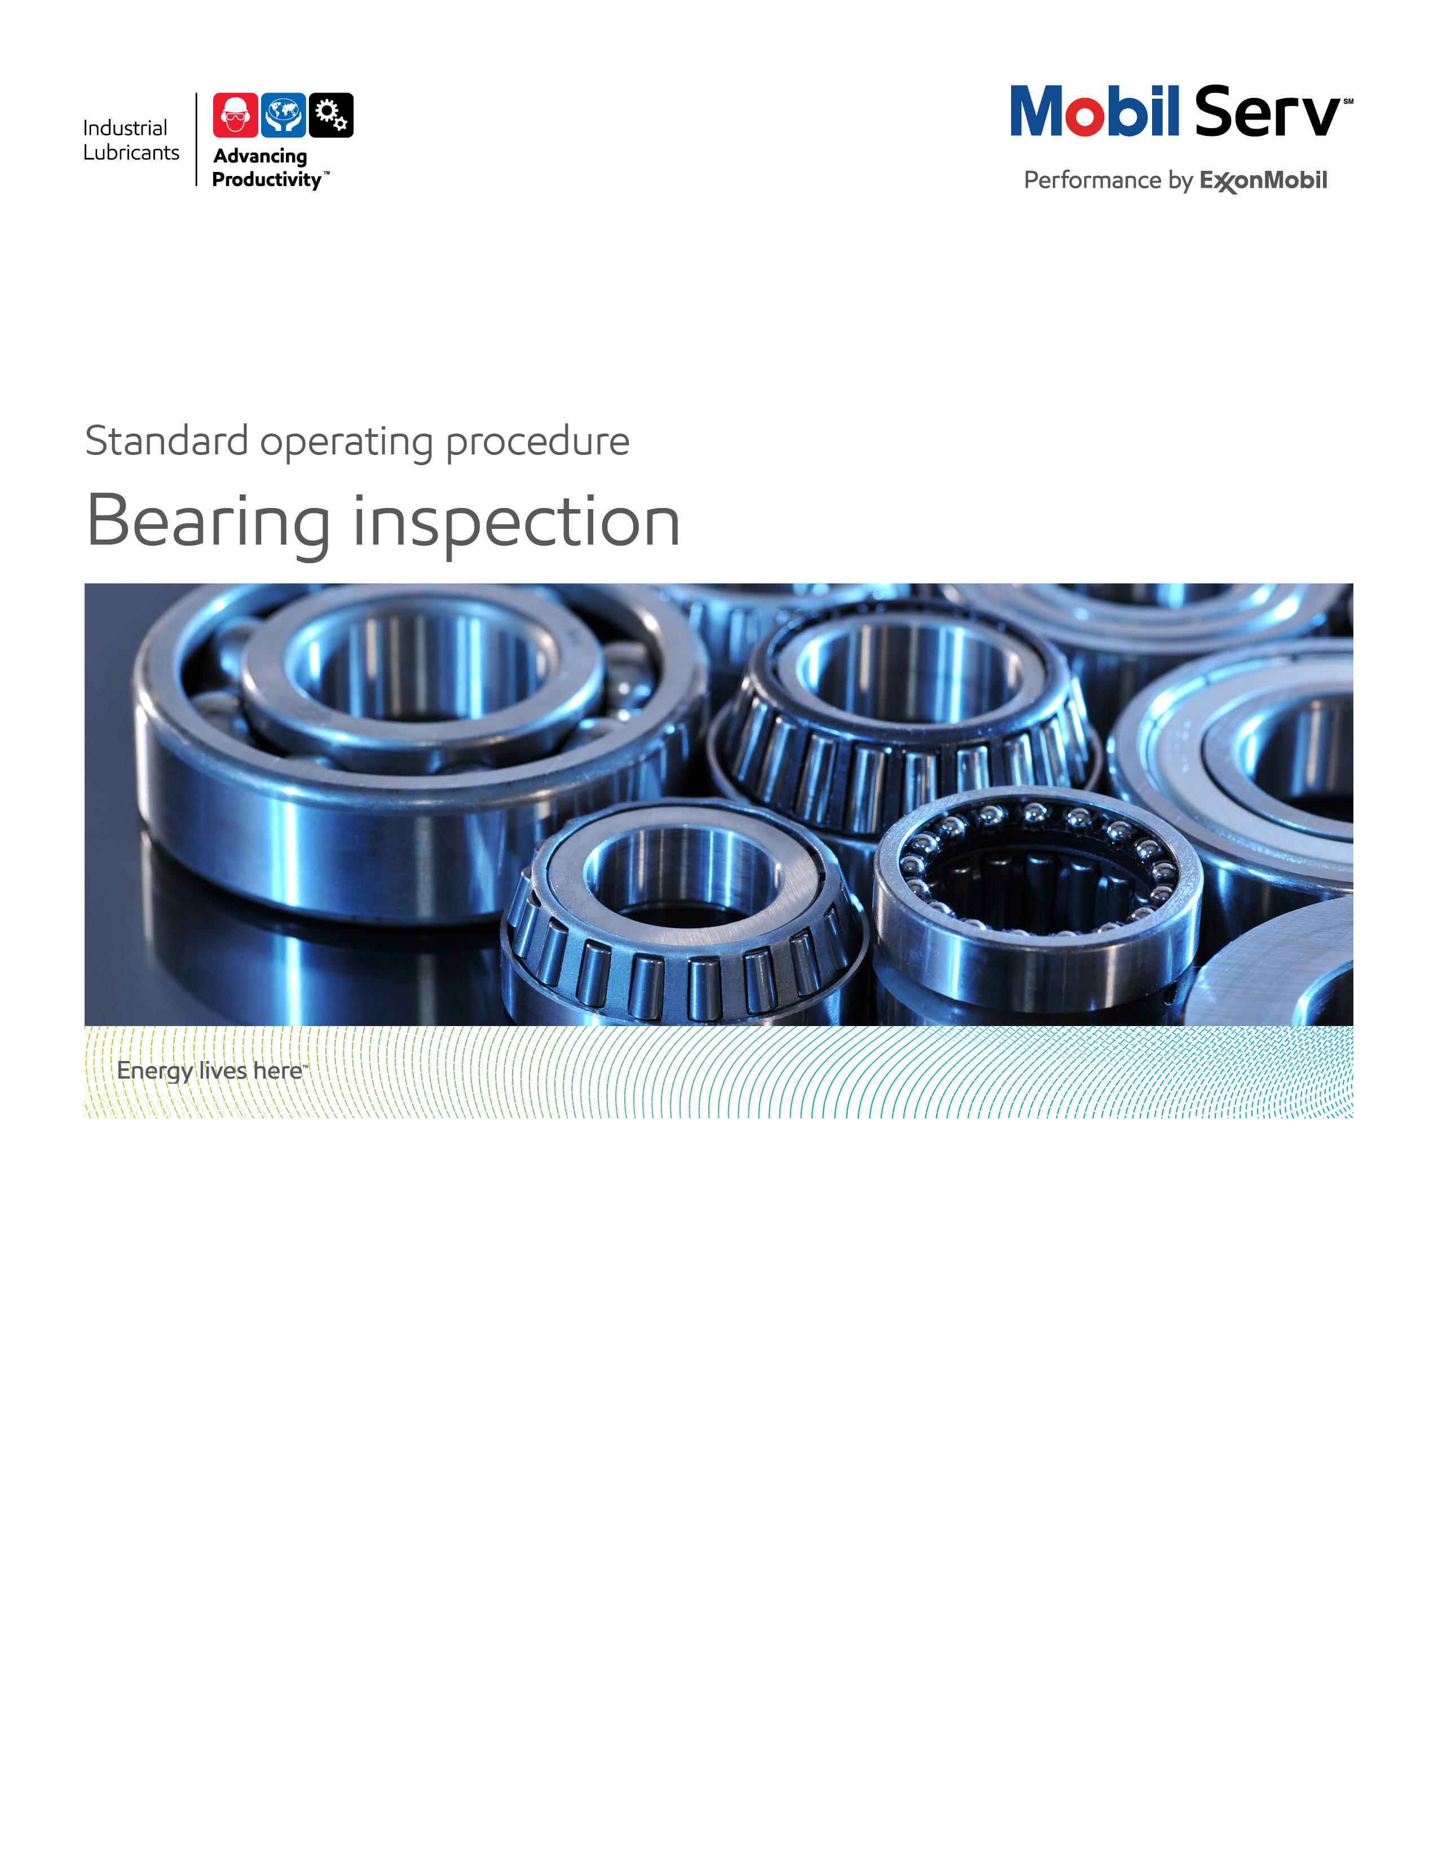

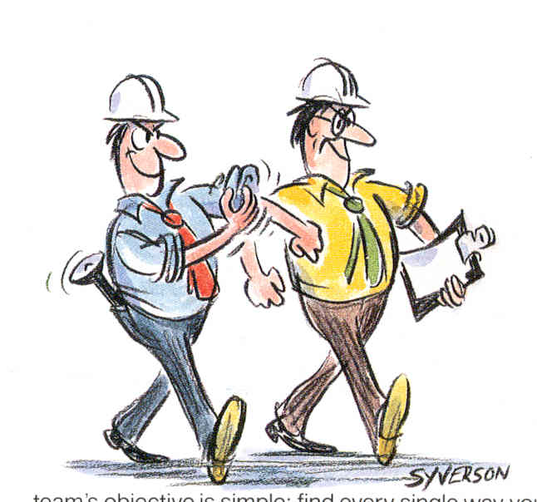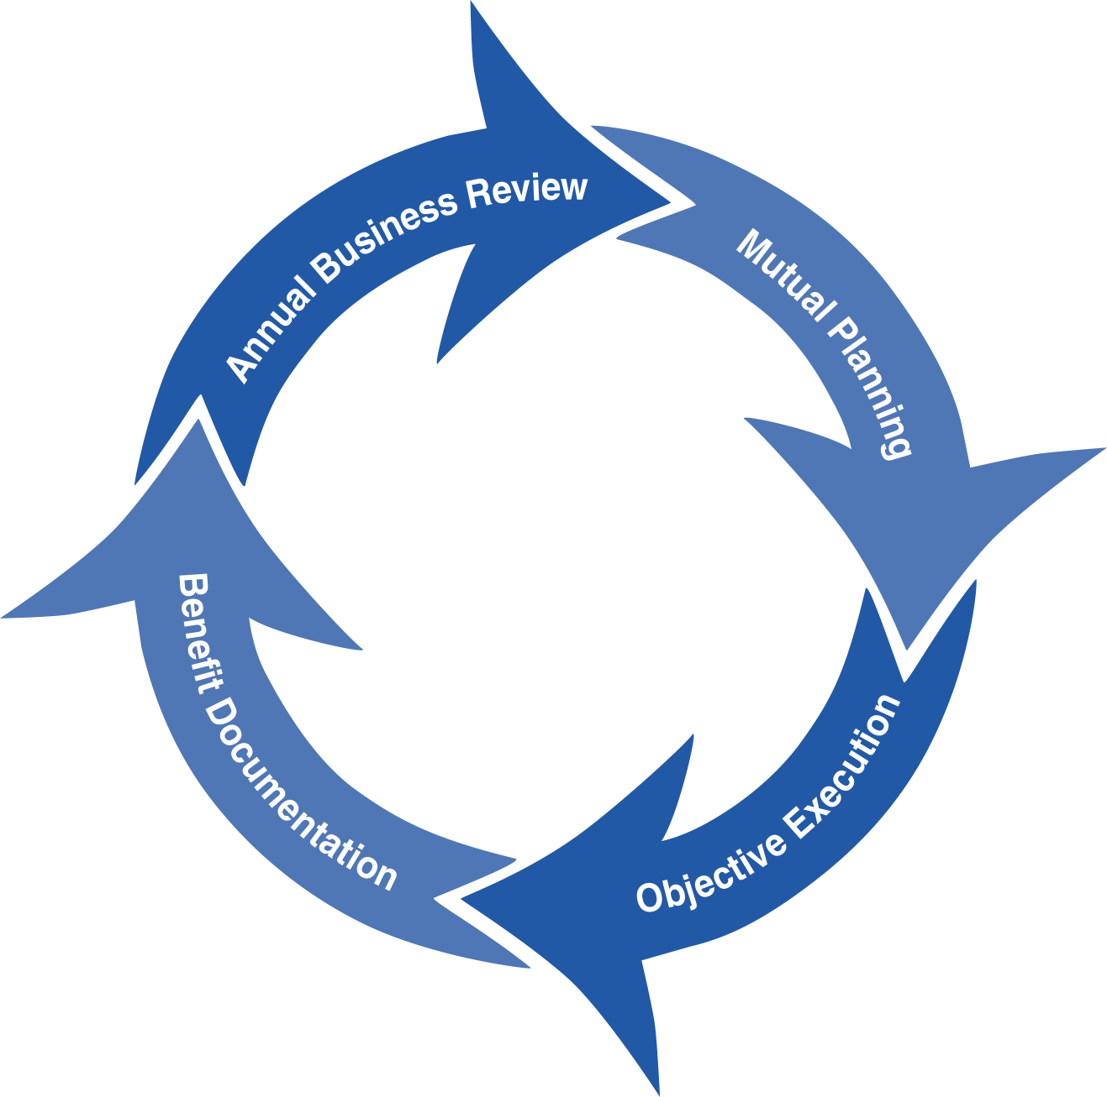
Standard Operating Procedure (SOP)
Read all of the steps in this SOP before beginning work. Follow customer labor requirements (eg respect Union work)

SOP: BEARING INSPECTION, ANTI FRICTION |  | DATE  7/30/2012 |  NEW  o REVISED  ___ Number |  | PAGE 1 of 6
TYPICAL CUSTOMERS  PULP & PAPER, PLASTICS, GEN MFG, OFF HIGWAY | WORK TYPE  BEARING INSPECTION | WORK ACTIVITY (Description)  Steps and recommendations to follow to properly inspect bearings.
DEVELOPMENT TEAM | POSITION / TITLE | REVIEWED BY/DATE |  | POSITION / TITLE
Ximena Pliego | Lubrication Engineer | Luis Rojas 07/30/2012 |  | FES Supervisor
Victor Jiménez | Lubrication Engineer | Bill Fuller 7/30/2012 |  | FES Advisor
 |  | Thomas A Schiff 8/13/2012 |  | FES Americas Manager
PLEASE UTLIZE ATTCHED GENERAL JSA AS GUIDANCE AND, IF YOU HAVE DONE A SITE SPECIFIC JSA.
PLEASE ASSESS YOUR OWN CONDITIONS OR SPECIFIC SAFETY REQUIRMENTS AND BE SAFE. http://intratta.na.xom.com/emdn/sbps/docs/safety/jsa/JSA_Wet_End_or_Dryer_Bearing_Inspection_Paper_Mill.xls
EQUIPMENT INDEPENDENT OF JSA DESIRED DOCUMENTATION
 CLIPBOARD OR TABLET PC   IR GUN   MASK   FLASHLIGHT   SAMPLE THIEF, BOTTLES & LABELS   RAGS   CAMERA  CHECK WITH CUSTOMER : OK TO USE OWN TOOLS OR MUST BE CUSTOMERS |  |  DAY OF - ENGINEERING SERVICE NOTICE (ESN) AS LEAVE BEHIND   FINAL - ENGINEERING SERVICE REPORT (ESR) WITH TOTAL COST of OWNERSHIP (TCO) SAVINGS  OTHER (SPECIFY)   BEARING INSPECTION WORKSHEET   EHL CALCULATION WORKSHEETS   GREASE FREQUENCY/QUANTITY CALCULATIONS   TCO – BEARING, PRODUCTION, ETC
TIME ESTIMATED TO COMPLETE THIS TASK NUMBER OF PEOPLE TO PERFORM THIS TASK
1 HOUR PER PROCESS SECTION |  | 1 -2, SHOULD CONSIDER CUSTOMER PERSONNEL
FREQUENCY TO PERFORM THIS TASK SKLLS REQUIREED TO PERFORM THIS TASK
DEPENDS ON CUSTOMER COMMITMENTS, USUALLY 1 -2 TIMES PER YEAR FOR PROCESS SECTION |  |  MECHANICAL APPTITUDE,   BEARINGS, COUPLINGS AND GEAR, eLearn   ACCOUSTICS   TEMPERATURE READINGS   GREASE BASICS   VIBRATION BASICS
JOB COMPETANCIES REQUIRED TO PERFORM THIS TASK, |  | TRAINING REQUIRED TO PERFORM THIS TASK
PRODUCT SELECTION – GREASE APPLICATION.  OFFER EXECUTION - INSPECTIONS - BEARINGS.  INDUSTRIES - PLASTICS & GENERAL MANUFACTURING  APPLICATIONS -BEARINGS.  BEARING INSPECTINGS |  |  PRODUCT KNOWLEDGE AND RECOMMENDATIONS   eLearn EQUIPMENT APPLICATION (BEARINGS)   TROUBLE SHOOTING PROBLEMS/FAILURE ANALYSIS   BEARING INSPECTIONS   EHL CALCULATIONS AND APPLICATION STUDIES   EXTERNAL BEARING CLASS; SKF, TIMKEN
OTHER RESOURCES REQUIRED OR SUPPORT
 TECHNICAL SUPPORT CENTER (tsc.amerias@exxonmobil.com)  Y tel. 001 800 966 2910 (SA) , 1800-662-4525 (NA)   www.mobilindustrial.com   www.looble.com   INSIDE SALES   BEARING NOMENCLATURE & CATALOG. http://vsm.skf.com/en-US/Catalog/~/media/Files/enUS/Automotive/457013_Web.ashx  TECHNICAL BULLETINS  http://intratta.n GREASE LUBRICATED PLAIN BEARING Pa.xom.com/emdn/sbps/technical/technical_bulletins/Grease_Lubricated_Plain_Bearings. pdf  http://intratta.nREGREASING ROLLER ELEMNT BEARINGS BEARINGSa.xom.com/emdn/sbps/technical/technical_bulletins/Regreasing_Rolling_Element_Bearings.pdf  http://intratta.nGREASE LUBRICATED PLAIN BEARINGS  BEARINGSa.xom.com/emdn/sbps/technical/lubrication_dispensing/Manual_Greasing/TIS-20%20Grease%20Lubricated%20Plain%20Bearings.doc  http://intratta.  EHAL CALCULATIUON WORKSHEETS  http://intratta.na.xom.com/emdn/sbps/technical/lubrication_fundamentals/Forms_and_Worksheets/EHL_Calculations.xls |  |  BEARING FAILURE MODES (SKF.COM)   GREASE FRECUENCY CHART   LTS (LUBRICANT TECHNICAL SUPPORT) LAB  TECHNICAL LINKS   SKF WEB PAGE  http://www.skf.com/portal/skf/home/products?maincatalogue=1&newlink=1&lang=en   BEARING ANALYSIS AND TROUBLESHOOTING  http://www.reliableplant.com/Read/22776/bearing-analysis-troubleshoot   BASIC WAER MODES  http://www.machinerylubrication.com/Read/1375/wear-modes-lubricated   BEARING FAILURE MODES  http://www.reliabilitydirect.com/appnotes/jbfail.html   NSK BEARING DOCTOR DOWNLOAD  http://www.nskamericas.com/cps/rde/xchg/na_en/hs.xsl/troubleshooting.html

PURPOSE - To describe the process of conducting a bearing Inspection either when component is disassembled or when in operation, with the desired reporting that provides the value back to the customer, to support the standard Marketing Offer.

(External Offer Sheet: http://intratta.na.xom.com/emdn/sbps/technical/engg_services/Americas/Bearing_Inspection.pdf

(Internal Offer Sheet: Place holder when available)

LOCATION | JOB STEPS
Preparation and Data Gathering for Bearing Inspection (before visiting Customer site) | Understand and gather the following information:  - What was the original design (type, OEM, dimensions) and has it changed?  - When was the bearing installed and by whom? Verify installation techniques.  - Was the bearing stored properly before installation?  - Prior to the failure, were there any changes in vibration, operating temperature, speed, load, maintenance pattern and/or lubricant type?  - Is the Loading (and what influences load; belt tension, pump curve) rated for application.  - Identify L10 life  - Identify bearing orientation; floating or fixed, retention ring installed.  - Record OEM lubricant recommendation.  - Type of lubricant - Grease or Oil currently in use. (Brand name)  - Identify grease application method (manual grease gun, centralized system. Cycle and quantity of greasing criteria)  - What type of inspections the customer is performing on the equipment (vibration analysis, photographic, historic data.)  TCO  (These are typical questions to obtain your “As Is” case. Use these to help justify your recommendations and to demonstrate value)  - Does the failure occur unexpectedly? If yes, how was production, how long was the downtime to repair the failed bearing? What’s the cost associated?  - How long did the previous bearing last and why was it replaced?  - What is the life of similar bearings on other machines at that location? What is the suggested bearing life?  - How many bearings do you keep at the warehouse for potential failures?  - What is the cost of the bearing to be replaced?  - What is the labor cost associated to replace the parts?  - How many hours do you spend on re-lubrication?  - How many bearings are replaced a year.  - What is the lubricant consumption?  - Quantity & re-lubrication frequency.  - What is the energy consumption rate?
Bearing Inspection - disassembled or in place still on the machine | - Notify operator of machine you are in the area conducting the inspection on the bearing.  - Review XOM JSA with site personnel.  - Using Bearing Inspection worksheet and record bearing component observations.  - Confirm Operating Conditions; bearing operating temperature, noise, vibration, shaft speed, ambient temperatures and loading (shock or steady operation), etc.  - Review blue prints (schematics) for bearing location.  - Confirming floating and fixed locations.  - Identify contamination levels and potential from the operation and oil analysis if performed.  - Pull a lubricant sample for analysis. Obtain any deposits from bearing and filers for analysis. Consider sending bearing components to LTS for investigative analysis (consult with Field Engineering Support Supervisor/Advisor).  - Identify and review what types of predictive tools are used to monitor bearing condition; oil analysis, vibration analysis, thermography, etc. Note any common issues/findings.  - Review potential grease misuse (mixing different grease in stock, overgreasing, and not greasing).  - Check oil levels and flow rates versus design  - Look for alignment & installation techniques (laser or manual and if there is data supporting these activities), as well as rotor balance.  - Check lubricant supply lines for cleanliness and signs that would impede flow.  - Inspect each part of the disassembled bearing and the rotor shaft if available, using the bearing inspection worksheet and bearing OEM failure mode guidelines.  - Look for abnormal wear patterns, discolorations, etc. on the outer ring, outer raceway, cage, rolling elements, inner raceway, inner ring, bearing locking rings/spacers/housings,  - Look for lubrication path ways on the bearing (lube grooves and lube holes), as well as shaft condition.  - Correlate the collected operational and maintenance data and tie the observed bearing component conditions to the operational and maintenance data to determine wear morphology and potential root causes.  - Provide recommendations  - If there is no Access to the damaged bearings ask for images, pictures.  - Take pictures of complete machine and close ups of inspected parts.  - Ask customer for assessment of what happened leading up to bearing failure.
Bearing Inspection - in operation | - Notify operator of machine you are in the area conducting the inspection on the bearing.  - Review XOM JSA with Site personnel.  - Use IR gun, thermography camera or temperature indicators to obtain bearing and surrounding component temperatures.  - Look for grease/oil leakage and contaminants in the area.  - Potential sources of contamination are; breathers, oil level indicators not  secured, poor seals or damaged bearing housing.  - Identify Grease/oil color, odor and consistency.  - Determine Re-greasing effectiveness by looking for grease fittings correctly covered and grease exhaust piping to function properly.  - Look for potential grease cross contamination (different colors).  - If oil lubricated, take a sample and send it for evaluation, preferably LTS.  - Check for proper oil flow, oil level indicator readings and lubricant supply lines for cleanliness.  - Verify proper lubricant is being used  - Take pictures of complete machine and close ups of inspected parts.  - Ask customer for assessment of what happened leading up to bearing failure.
EHL calculations and report preparation | - Use the Mobil EHL workbook to determine proper film thickness to determine lubricant to be used. Identify if shock loading occurs for use of EP lubricants.  - For grease lubricated bearings:  - Use grease re-grease frequency chart, consider contamination levels, bearing position, water exposure, etc.  - Review grease compatibility chart if applicable (e.g. recent conversion or  suspected cross contamination)  - Prepare a comparison chart with features and benefits of the recommended product.
Proposal/ESR to customer | - If applicable write an Engineering Service Notice (ESN) after you leave customer site to review preliminary findings and recommendations.  - Once you have identified the root cause failure analysis and recommendations, write an Engineering Service Report or a Proposal, identifying potential customer benefits based on the execution of ExxonMobil recommendations. Use pictures to highlight supporting ideas and inspection details of equipment.  - The ESR or Proposal should include savings using as many TCO categories as they apply, revenue enhancements, expenses, assets, process improvements, etc  - The ESR or Proposal should include next steps, commitments and follow up procedures.
Sending customer reports | - It is recommended to send the report directly to the maintenance contact, then arrange a meeting to discuss live and obtain approval. Once the report has been approved you may write a performance summary and share with other departments.
Follow up | - In the next visits to customer site take a look to the corrective actions implemented as a result of your report.
Feedback about this SOP - Send to Field Engineering Advisor/Supervisor

DOCUMENTING YOUR WORK - The Bearing Inspection is used to assure that the bearings achieve their maximum life and verify the performance of Mobil premium and flagship lubricants. The Bearing Inspection Worksheet can be used as a guide to assist in the inspection and preparing an Engineering Service Notice or Engineering Service Report. Proper placement is an Appendix.

TCO is a process to quantify improved profit through the implementation of an effective lubrication program. In order to document savings involved in a partnership between the customer and Mobil Industrial Lubricants, the following categories of value-added savings will be reviewed:
- Revenues
- Assets
- Processes
- Expenditures
The TCO Worksheets are the preferred format to include in your report. Proper placement is an Appendix. Additional guidance will incorporate our messaging of TCO to include Sustainability, Safety and Productivity relationships.

Expenditure Reduction - reduced bearing lubricant purchase costs are the most typical expenditure savings. These only result from the offset of extending lube application intervals from the previous lubricant or greases against the increased price of Mobil products flagships and premium. Find out how much is the consumption on an annual basis.
Expenditures could also be the cost of bearings replacement and ancillary equipment damage.

Process Improvement - the hourly wages (including burden) for personnel to perform existing tasks e.g. replaces the grease or changes some bearings. If bearings replacements or lubricant change outs are reduced, use these to determine Process improvements. If lubricant usage is reduced, use the time to handle drums and the time to dispose of used lube to determine Process improvements.

Revenue Enhancement - any repair for bearing failure may be repaired during normal maintenance and reduce the potential for downtime. “Unscheduled Downtime”, results in lost production and most often, scrapped parts or material. This may allow the customer to plan for a replacement during a planned outage instead of an emergency shutdown

Asset Improvement - use the customers "cost to carry" inventories. This is used from the Expenditures components for example, if you reduce the quantity of lubricant needed, take that amount cost and multiply by the "cost to carry" to determine the Asset value.

Refer to Expenditure Reduction, Process Improvement, Revenue Enhancement, and Asset Improvement to develop TCO. The Total Cost of Ownership (TCO) Database has many bearing typical costs in it, or consults with the OEM or bearing distributor to finalize your TCO

http://intratta.na.xom.com/emdn/sbps/technical/TCO_Databases.html

Include any “negative” components of TCO from your recommendations; new lube systems, filtration, water removal, enhanced predictive monitoring, increased labor (to do the job correctly the first time), new equipment; e.g. to replace under sized equipment.

Documentación Links:

Product Application
http://intratta.na.xom.com/emdn/sbps/technical/product_apps/prod_apps_bearings.html

Model Report
http://intratta.na.xom.com/emdn/sbps/technical/model_doc/esr/Sector_Type/Mining_and_Construction/Bearing_Inspection_OffHighway.pdf
http://intratta.na.xom.com/emdn/sbps/technical/model_doc/esr/Sector_Type/Paper_Forest/Bearing_Investigation_Paper.pdf
http://intratta.na.xom.com/emdn/sbps/technical/model_doc/esr/Sector_Type/Steel/Bearing_inspection_Primary_Metal_example_1.pdf
http://intratta.na.xom.com/emdn/sbps/technical/model_doc/esr/Sector_Type/Steel/Sector_Steel_Primary_Metal_Service_Type_Bearing_Inspection_Example_2.doc

Work Sheet
http://intratta.na.xom.com/emdn/sbps/technical/pred_maint/Equipment_Inspections/Magnetic_Induction.ppt

